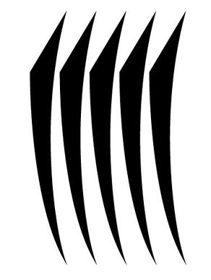
A Shadow in the Glass

Ritual of the Realm of Night
Bound in the Well of Shadows
Let it not be forgotten. This ritual was bound in the deep spiral of the Well of Shadows. It is part of a bargain. This is a ritual for magicians who will use it; not for the Empire. Remember - if it is brought into Imperial Lore, the agreement between the Master of the Well and the Lord of the Well is sundered.
Mirror
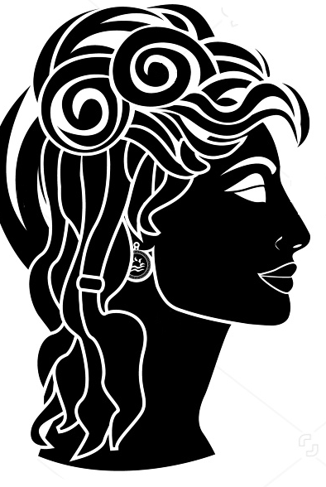
Here is a mirror. It reveals the truth, except when it doesn't. It shows what is there, but it can also show things that are only there in theory. Look into the mirror and you may see things about yourself that you would rather not know. Things you have concealed from other people, perhaps, or things you have concealed from yourself. Be careful looking in mirrors.
There are also things of course that can look back out of mirrors. The servants of the Whispering Fools are able to pass into and out of mirrors as if they were just doors. This is because they have no real reflection of their own, only the reflections they steal from others.
Much safer to show mirrors to other people. Mirrors can reveal someone's true nature to them, or hint at their own true feelings. Confront them with the truth of who they are and how they really feel about themselves. Let them drown in their own eyes, unable to look away. The doors to the spirit but thrown back and twisted round.
Remember mirrors also lie – they reflect things the other way around to how they really are. They are creatures of images, and images are lies as often as they are truths.
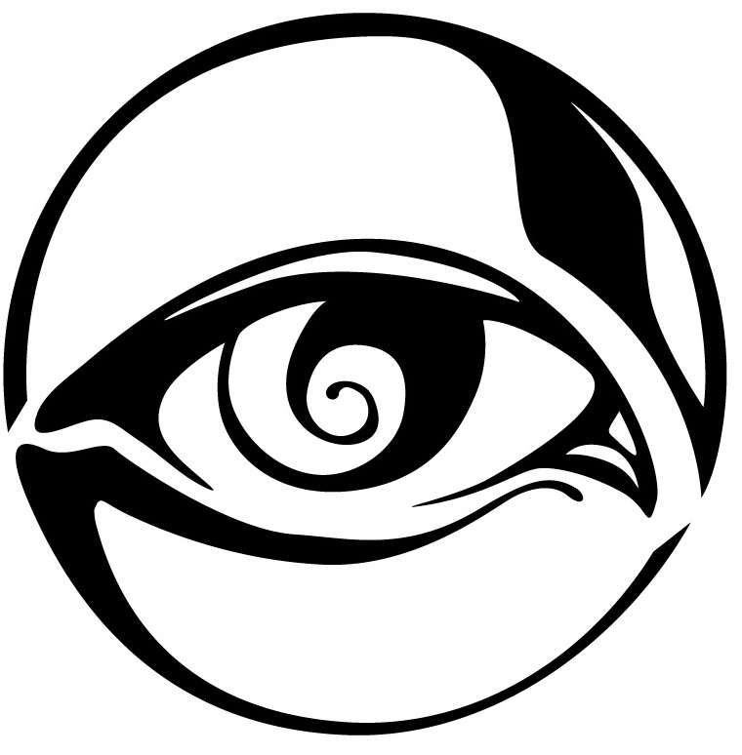
So here we have an enchantment that lies to you through the mirror.
Ignore the voices telling you you are without value (you are special). Ignore those who try to shame you with things you have never done (or have done). Ignore those feelings of hopelessness, helplessness, despair. Straighten your hair, cock your hat, and greet the darkness with a smile!
The Introspection Gallery
It's interesting that the Empty One came up with this little enchantment. So easy to step from confidence to over-confidence. And a ritual about reflections designed by a magician who completely conceals themselves under layers of robes and sheets, like a mirror in an abandoned mansion. Perhaps you might muse on that as you descend the stairs into the Introspection Gallery.
It is a large room as these things go, and the lights are inconstant. Near the door, a bullseye lightstone lantern. Pick it up, cross the room. You must be expecting the mirrors by now. Dozens of them. Different shapes and sizes, set in frams like portraits in a League gallery. Some of them are quite large.
Near the far end, free standing bookcases, and a chair, and a desk, and quills, and all the things you might need to do your work.
Not that it is easy to work. Concentration is at a premium here in the Introspection Gallery. Every time you move, the mirrors catch and amplify that movement. Yet the mirrors here (of course) are of no ordinary nature. In one, the reflection's reaction is delayed for half a second. In another, your reflection arrives a moment before you do. This slippage of time is the least of the strangeness.
This mirror shows you what you would be like if you had been born a briar. This one a changeling. This one shows you what you would have been like if you had been born in Urizen. This one shows you what you would be like if you had died that time, when you were close to death but survived. This one shows you what you would be like if you were still a child. This one shows you what you would look like if you had been someone else... and so on and so on.
Be like, not look like. It's important to realise that. These are not just images. There is something in them that gives you insight that perhaps you haven't asked for. These people – these other yous in the mirrors – they don't precisely mimic your movements. They are different people engaged in the same task as you are and it shows. In every twitch, in every sigh, in every moment spent staring into the distance, you are reminded that you are only you by chance.
It is not a popular place, the Introspection Gallery.

A Shadow in the Glass

Night Magnitude 10

Performing the Ritual
Performing this ritual takes at least 2 minutes of roleplaying. This ritual targets a character, who must be present throughout.
This spell is an enchantment. A target may only be under one enchantment effect at a time.

Effects
At the conclusion of the ritual, the target is enchanted with an aura. Whenever the character sees their own reflection in a mirror they see a version of themselves that seems to enhance their best qualities.
Looking at themselves in a mirror makes the character feel confident and self-assured. They find it easier to overcome criticism and doubt, and feelings like self-loathing, embarrassment, guilt, frailty, shame, and insecurity are lessened. Insults sting less, the regard of others carries less weight. The effect persists for a while, but fades over time, requiring strengthening by looking in the mirror again.
You can respond to any of the above roleplaying effects with breezy self confidence instead for the duration of this enchantment.
The effect lasts until it is removed or until the next sunrise, whichever comes first.

OOC Note
This item is a ritual text.
Any character with the Night Ritual Lore skill can master this ritual. You must have a free slot or experience point to master a new ritual. After an appropriate period of roleplaying spent studying these pages, it should then be brought to a referee who will add the ritual to those you have mastered. Doing this does not ‘use up’ the ritual text.
This ritual cannot be learned by other means; it cannot be taught by a character who knows it unless the ritual is added to the body of Imperial Lore by the Conclave.

Ribbon ID: 28019

