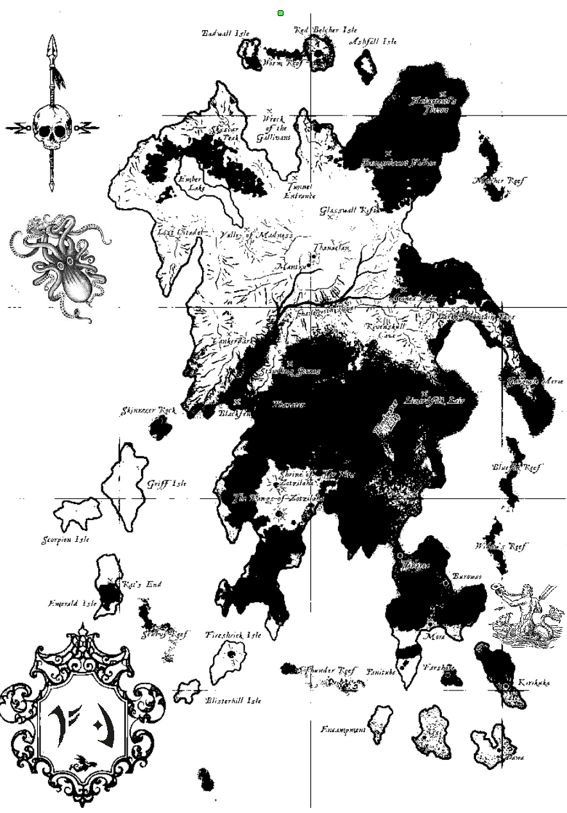
This map is a form of arcane projection. It can be used by a Freeborn coven as if it were a ritual of the Summer Realm of magnitude twenty. The ritual targets all fleet resources belonging to characters from the nation of the Brass Coast During the coming season, any fleet captain of that nation who engages in the privateering or foreign trade actions will have adventures that result in them gaining additional random resource production. This item expires at the end of the Winter Solstice.

This map is a form of arcane projection. It can be used by a Dawnish coven as if it were a ritual of the Summer Realm of magnitude twenty. The ritual targets all fleet resources belonging to characters from the nation of Dawn. During the coming season, any fleet captain of that nation who engages in the privateering or foreign trade actions will have adventures that result in them gaining additional random resource production. This item expires at the end of the Winter Solstice.

This map is a form of arcane projection. It can be used by a Imperial Orc coven as if it were a ritual of the Summer Realm of magnitude twenty. The ritual targets all fleet resources belonging to characters from the nation of the Imperial Orcs. During the coming season, any fleet captain of that nation who engages in the privateering or foreign trade actions will have adventures that result in them gaining additional random resource production. This item expires at the end of the Winter Solstice.

This map is a form of arcane projection. It can be used by a Highborn coven as if it were a ritual of the Summer Realm of magnitude twenty. The ritual targets all fleet resources belonging to characters from the nation of the Highborn. During the coming season, any fleet captain of that nation who engages in the privateering or foreign trade actions will have adventures that result in them gaining additional random resource production. This item expires at the end of the Winter Solstice.

This map is a form of arcane projection. It can be used by a League coven as if it were a ritual of the Summer Realm of magnitude twenty. The ritual targets all fleet resources belonging to characters from the nation of the League. During the coming season, any fleet captain of that nation who engages in the privateering or foreign trade actions will have adventures that result in them gaining additional random resource production. This item expires at the end of the Winter Solstice.

This map is a form of arcane projection. It can be used by a marcher coven as if it were a ritual of the Summer Realm of magnitude twenty. The ritual targets all fleet resources belonging to characters from the nation of the Marches. During the coming season, any fleet captain of that nation who engages in the privateering or foreign trade actions will have adventures that result in them gaining additional random resource production. This item expires at the end of the Winter Solstice.

This map is a form of arcane projection. It can be used by a Navarr coven as if it were a ritual of the Summer Realm of magnitude twenty. The ritual targets all fleet resources belonging to characters from the nation of the Navarr. During the coming season, any fleet captain of that nation who engages in the privateering or foreign trade actions will have adventures that result in them gaining additional random resource production. This item expires at the end of the Winter Solstice.

This map is a form of arcane projection. It can be used by an Urizen coven as if it were a ritual of the Summer Realm of magnitude twenty. The ritual targets all fleet resources belonging to characters from the nation of the Urizen. During the coming season, any fleet captain of that nation who engages in the privateering or foreign trade actions will have adventures that result in them gaining additional random resource production. This item expires at the end of the Winter Solstice.
This map is a form of arcane projection. It can be used by a WInterfolk coven as if it were a ritual of the Summer Realm of magnitude twenty. The ritual targets all fleet resources belonging to characters from the nation of the Wintermark. During the coming season, any fleet captain of that nation who engages in the privateering or foreign trade actions will have adventures that result in them gaining additional random resource production. This item expires at the end of the Winter Solstice.

This map is a form of arcane projection. It can be used by an Varushka coven as if it were a ritual of the Summer Realm of magnitude twenty. The ritual targets all fleet resources belonging to characters from the nation of the Varushka. During the coming season, any fleet captain of that nation who engages in the privateering or foreign trade actions will have adventures that result in them gaining additional random resource production. This item expires at the end of the Winter Solstice.

