### Net of the Gulls

### Autumn Magnitude 2

### 

### Performing the Ritual

Performing this ritual takes at least 2 minutes of roleplaying.

While performing this ritual, a contributor must write a message on a piece of paper, which they should read aloud. The paper must have a hole cut in its centre, no less than the size of a five-Throne coin.

The message must take the form of a poem, formed of up to 10 rhyming couplets. Each couplet should be no more than 30 words long. The poem should detail the ways in which a named individual has recently lied, cheated or manipulated others to gain power. That individual should be present throughout the ritual, and may be a contributor.

All contributors and the named individual must conceal their features for the duration of the ritual.

### Effects

When the ritual is complete, the specially prepared paper disappears and is received by the Autumn Eternal Mazen; the paper should be given to the referee.

This ritual does not transfer pictures or items.

The Eternal is peripherally aware of who sent the message.

### OOC note

This item is a ritual text.

Any character with the Autumn Ritual Lore skill can master this ritual. You must have a free slot or experience point to master a new ritual. After an appropriate period of roleplaying spent studying these pages, it should then be brought to a referee who will add the ritual to those you have mastered. Doing this does not ‘use up’ the ritual text.

This ritual cannot be learned by other means; it cannot be taught by a character who knows it unless the ritual is added to the body of Imperial Lore by the Conclave.

### Ribbon ID: 12992

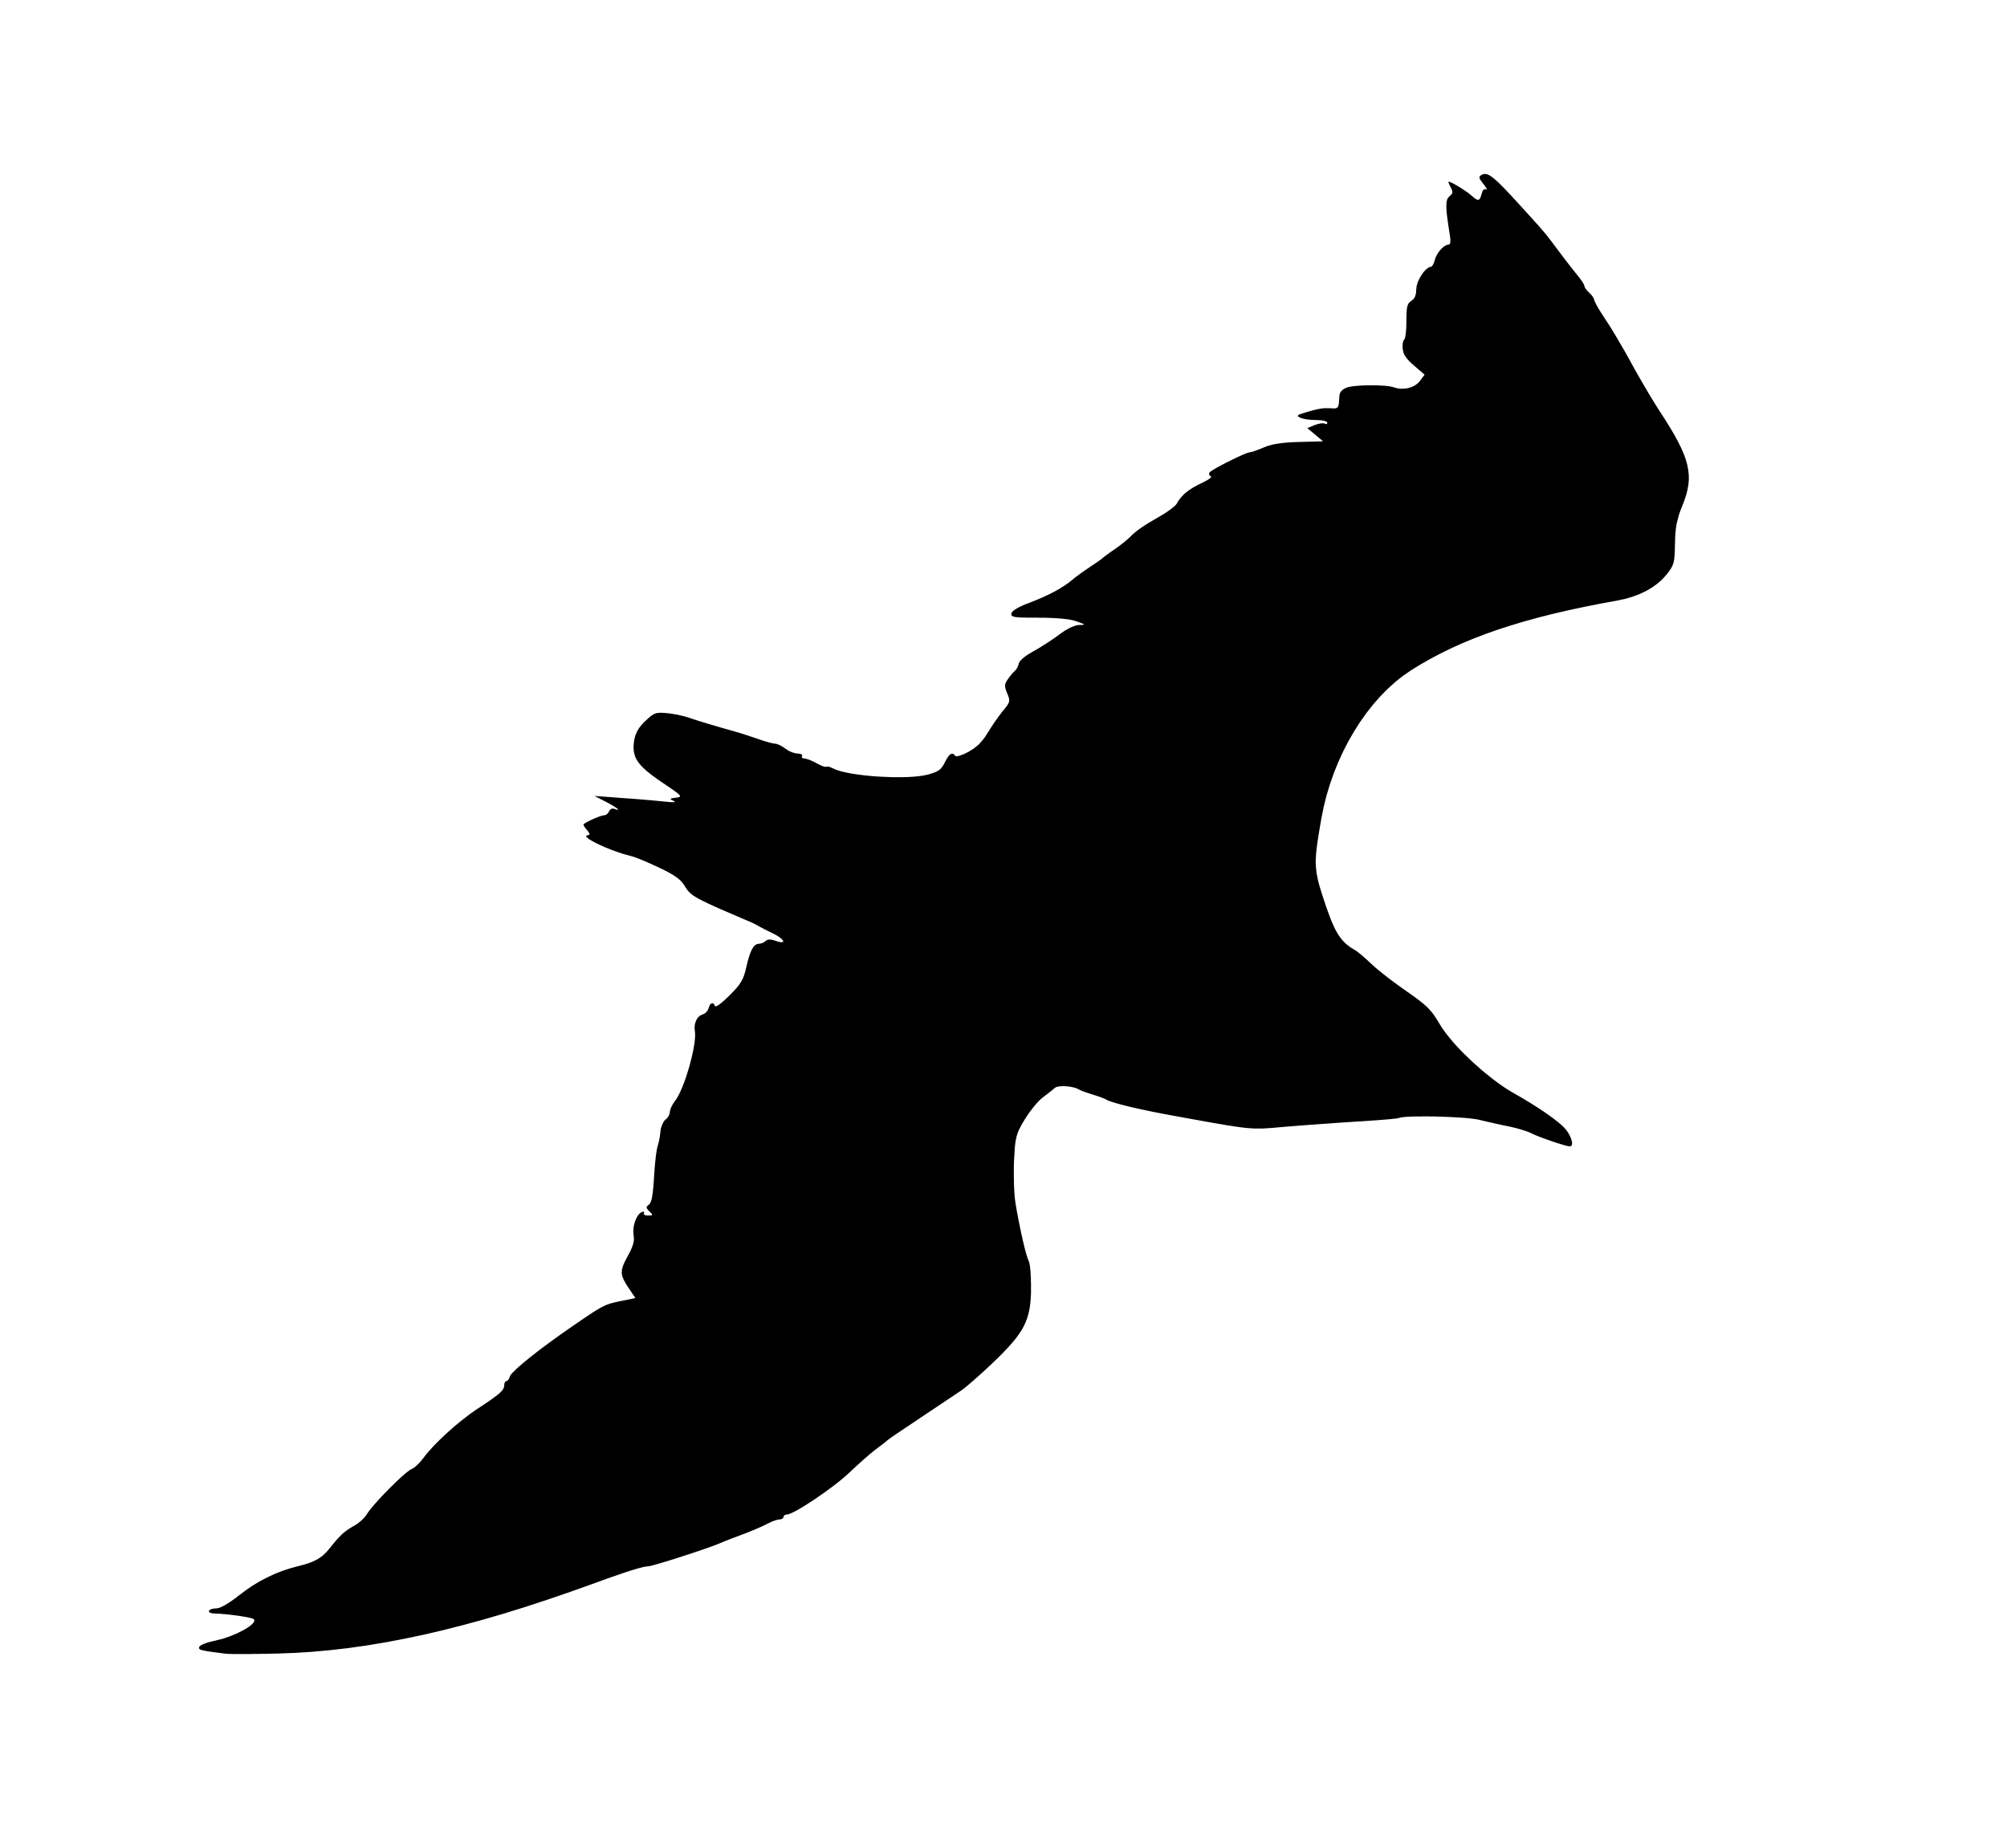

*Net of the Gulls*

*Ritual of the Realm of Autumn*

*Codified by Jannem, with the careful guidance and dictation of Mazen of the Many Faces.*



*A Ritual Text From The Mouths Of Mazen the Many-Faced, who is the Gull-Catcher, who is the Unseen Hand, who is Løgner, who is Lutkar!*

This Ritual has a name! It is “Net of The Gulls”! Yes!

This ritual is Simplicity Itself! Yes!

It transports a message, to we that is Mazen the Many-Faced, a Record of Deeds Done that Please Us, of Victories Achieved! Have you ever heard of such Virtue?! Yes!

Is this not an opportunity for you to express your pride at your own cunning?! See how, I, Mazen the Generous, Mazen the Understanding, grant this to you! We are the Gull-Catcher: fly to us! Yes!

We bind ourself to receive these messages so long as the Brass Coast stands as a nation within the Empire! This We swear, upon the Brass Magistrates called the Lictors! Yes!

We make no promise at a response!

Impress us!

*The Details Of How To Cast The Ritual Known As Net Of The Gulls*

To Cast the Net of the Gulls, prepare a Message! The Message must be in the format appropriate for such things! We will receive no other format! This is the most important part! Yes!

The format is Simple! The parchment on which the Message is written must have a hole in its centre representing your wealth! At least five Thrones of hole! Yes!

It must have up to ten pairs of lines naming and exalting someone! Each pair must rhyme! Each pair must have no more than thirty words! Yes!

It must talk of deeds of a deceptive and manipulative nature! It should tell of Lust for Power! We will be pleased if the tales are True! We will be pleased if the tales are Interesting! Yes!

Such a thing is possible for us to receive by our power and cunning! Yes!

If one were to inscribe upon it Queros, as a final flourish: it would certainly please us further! Yes!

Look! We Write it Here! See It Dance! Yes!

