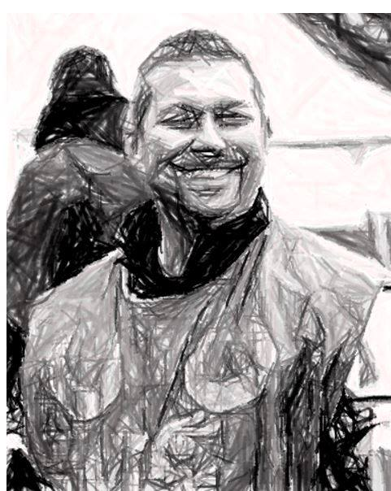
WANTED!

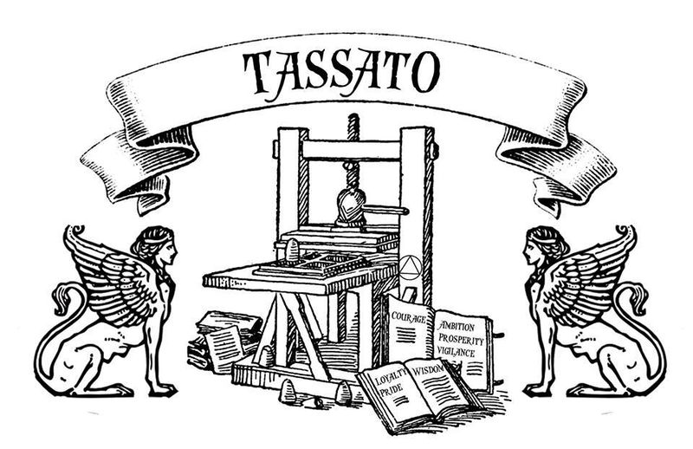
Earl Bohemond De Rondell
For attempted Theft of the Imperial Throne
The Imperial Synod failed to condemn this vainglorious, self-important showboat; his tyrannical lust for power is matched only by his love for the sound of his own voice!
REWARD! An Empire free from the boot-heel of this vicious unprincipled savage in Dawnish garb!

