Fury of the Black Shuck

Ritual of the Realm of Spring
Codified this bright mooned Autumn 378YE by Cnaeus of Endsmeet

A digression on the Claw
The Claw is a constellation of four stars visible all year round. It spends most of the autumn and winter months relatively close to the western horizon only rising to its peak (roughly halfway to zenith) during mid-spring. Even when it is not visible you can feel it, behind the clouds or hidden by the cruel eye of the sun.
The brightest of the four stars (the second of the four as you look left and right) is located almost directly above the tail of The Stork. As if it were about to strike, as if it had crept up on the Stork and was ready to assault it. The concept of predation, about to assail the concept of precise restraint. If it can be made to bleed, it should be made to bleed. Strength through survival.
The Claw represents the primal natural law; things struggle and then they die anyway, in pain and confusion, when they do not expect it. Nature is red in tooth and claw and stinger and pincer and talon and barbed ovipositor.
Where the Claw strikes blood is shed; the skin is torn and the flesh is torn and the bone is torn and shattered. Violence begets violence; I dare the most committed pacifist to sit quietly while the Beast charges toward them the spittle flying the howling the roar, the fang and the talon and the claw. Peace begets death through violence.
The Claw can represent struggle against the odds or defiance of what seems a foregone conclusion; because you must struggle, you must fight, because when you cannot struggle you are become meat even the sheep even the goat will struggle when you catch it's soft neck between your jaws, it fights the hound even though it has no weapons with which to fight and is all over save the crunch and the tear. It fights to live, because living is warm and living is light and living is so so short, and death is cold and dark and forever and ever.
In Wintermark the Suaq call it the Tusk. They tell a pretty tale of a walrus but I think they do it to trick the southern people because the walrus tusk bears no jolly warning it bears death it is a weapon it is the Fang made from short-blade to greatsword. I had a tusk once from a great beast of the northern ice, a dire walrus. It had been carved and set with silver runes and I used it as a walking staff I think it was perhaps five feet long and still sharp as a spear I think I killed a deer with it once but then I lost it.

Magic
The Claw is a destructive force but the astronomancer would tell you that it is not a negative one but they are lying to you.
It is commonly invoked in rituals which deal with battle, inflicting injury, disaster, bloodshed and war. It is like using a raging forest fire to cook a baked potato; like building your spire on the edge of a churning caldera so it will be well lit at night.
Warrior magicians seem to regard the Claw as a good constellation to make their workings under; its physicality and the violence it promises can be channelled into the ritual to provide the right mood and energy. Because they know better than any other magician the rush of the blood and the sweat and the singing in the veins that comes from slaughtering the weak from touching your fingers to the pool of hot blood and raising them to your mouth and licking the sweetness and the heat from them.
The claw cuts all ways. Those who live by the claw die by the claw. I will not die by the claw. I will not die by the claw. I will not die by the claw. I will not die by the claw.

Tulpas
The thought-forms of the Claw are clawed beasts.
Some of them fuse man and beast together.
Some of them are hounds. Black hounds, dark hounds, hounds of living shadow that stalk and watch and tear and hunt. I did not kill those people, the black hounds did. The black hounds chased them down and brought them to the ground and tore at them with their claws and their jaws and they were the ones who ate their flesh and howled at the stars, howled their fury and their lust and their triumph in the hunt and the slaughter.
They talk of the black shucks in the Marches, mostly, but I found them in the mountains of my home. They say in the Marches that they pad pad pad behind people on the roads at night under the empty mood when the Claw is in the sky and that you must not look at them or acknowledge them or they will kill you but they also say that the black shucks will protect travellers from robbers and orcs and that sounds to me, sounds so much, like wishful thinking there was no protection in them when they rode me and ran with me and I was with them also.
I brought this ritual back with me from the deeps but I did not want to write it down, I did not want to share it and then the black shucks came and they watched me while I slept and they waited for me, creeping closer, always their eyes on me their eyes full of stars, and I said “No I will not write this it will let you ride other men and other women and even orcs – oh Virtues orcs ridden by the black shucks full of their rage and their fury the fury of the stars that is ageless and devastates worlds.”
But I am weak.
What can be broken, must be broken.

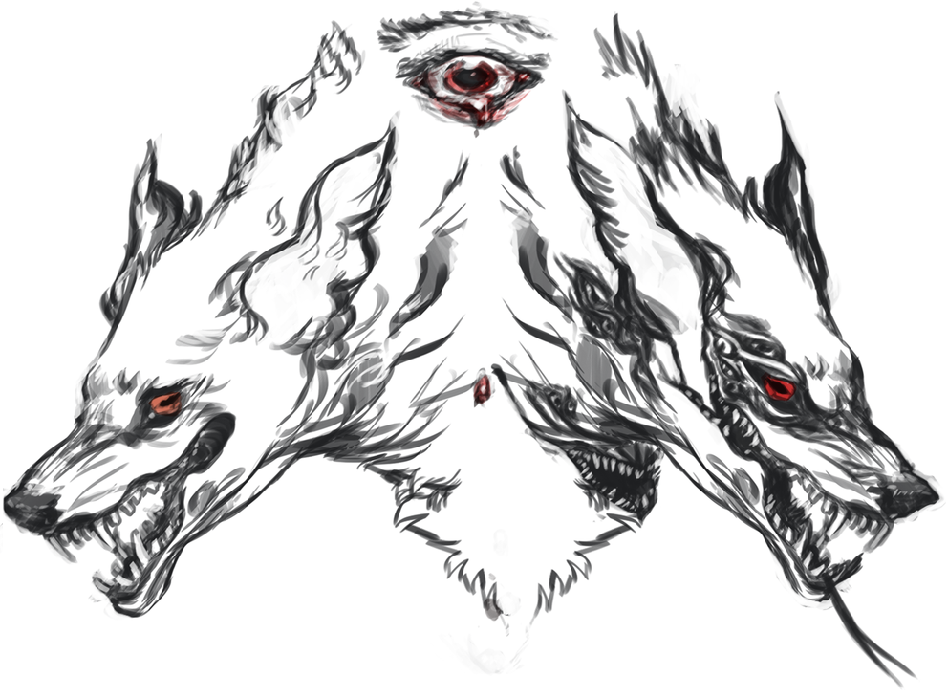

The Enchantment of the Back Shuck
This potent enchantment aligns the target with the fury of the Spring realm, and uses the astronomantic constellation of the Claw as a conduit. The target is closely touched by the power of those dangerous stars, and there is potentially a danger of permanent insanity (or of a long-term alignment with the Claw - which amounts to the same thing) if the ritual is used too often on the same target.
While this ritual provides a significant boost to the ferocity of the target, it also grants them strength and predatory perception that allows them to cripple or maim lightly armoured or unarmoured opponents.
Unfortunately, the nature of the enchantment is such that magical methods used to try and control the rage that burns inside the targets is likely to instead trigger a furious rampage. Of course, if the right candidates are chosen to be the subjects of this ritual they can instead embrace such magically created tranquility and resist their baser urges. I talked this to one of the sentinels who examined the preliminary form of this ritual at Endsmeet commented that this could be a powerful teaching tool - an Urizen who could confront and master their darkest, most blood-thirsty urges through the auspices of this enchantment would surely gain insight into their own personal arete as a consequence.
But then she had no idea what she was talking about and I was not ready to show her what the black shuck is really like when it slips into your spirit and joins with you and fills your eyes with stars.
Performing the Ritual
Evoke the Claw.
Howl and cut your target.

Fury of the Black Shuck

Spring Magnitude 24

Performing the Ritual
Performing this ritual takes at least 2 minutes of roleplaying. This ritual targets a character, who must be present throughout.
This spell is an enchantment. A target may only be under one enchantment effect at a time.

Effects
The target gains the ability to call CLEAVE three times each day when striking a single blow with any one-handed weapon that is between 24” and 42” long. If the target has the weapon master skill then you can use the skill with any weapon up to 84” long.
While under the enchantment the target experiences potent roleplaying effect: they are filled with a barely-contained rage that causes them to lash out at anyone or anything that frustrates them. Controlling this rage requires a visible effort of will. The target will also regularly hallucinate large, black hounds with glowing eyes that watch them whenever they are alone, especially at night.
In addition, they can respond to any roleplaying effect that would inspire feelings of calm, peace or tranquility by becoming extremely angry and lashing out at what they perceive to be the source of the effect.
The effect of the ritual lasts until the start of the next Profound Decisions Empire event.

Additional Targets
This ritual can affect additional characters from the same banner. Each additional character increases the magnitude by 15. Additional characters must be present throughout.

OOC note
This item is a ritual text.
Any character with the Spring Ritual Lore skill can master this ritual. You must have a free slot or experience point to master a new ritual. After an appropriate period of roleplaying spent studying these pages, it should then be brought to a referee who will add the ritual to those you have mastered. Doing this does not ‘use up’ the ritual text.
This ritual cannot be learned by other means; it cannot be taught by a character who knows it unless the ritual is added to the body of Imperial Lore by the Conclave.
A ritual text contains sufficient information that any coven that holds one may use it to attempt to duplicate the effect of the ritual spontaneously, exactly as if the ritual text were an arcane projection.

