SOLD TO SLAVERS!
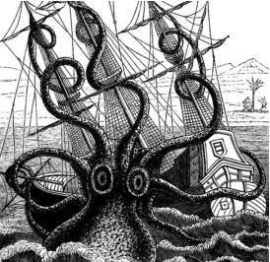
The Senate has prostituted the PROSPERITY of the Empire to FOREIGN HEATHENS!
The SLAVES in ASAVEA groan in their bondage as the COURAGE of the Empire has been frittered away by TRAITORS! We are bought and paid for!
And all it took was a THREAT … and the Senate crumbled like an unmortared wall! How dare these IDOLATORS even think of raising their hands against our Empire?
WE SHOULD HAVE SENT THE SMUG ASAVEAN BASTARDS HOME WITHOUT HANDS TO RAISE!
Instead the MEWLING POPINJAYS in the Senate have sent them home with FIFTY WAINS OF WEIRWOOD! Not satisfied with that treachery, they have CHAINED every Imperial captain with for the benefit of a FOREIGN POWER! With the COLLUSION of our Senate a foreign power has levied a FOUR HUNDRED CROWN tax on the people of the Empire!
These venal devils should QUAKE WITH FEAR when Imperial ships come into sight! They should be HONOURED to trade with our merchants, and if our AMBITIOUS corsairs choose to take their goods as TRIBUTE then THIS IS AS IT SHOULD BE!
Our LIBERTY has been stolen! Our PRIDE has been trampled! The COWARDS in the Senate must be held to ACCOUNT! DEMAND that the Synod root out the SNIVELLING DOGS who have WHORED our Empire to the idol-worshippers!
TAKE BACK IMPERIAL PRIDE!

