Colin Buckler of Odd
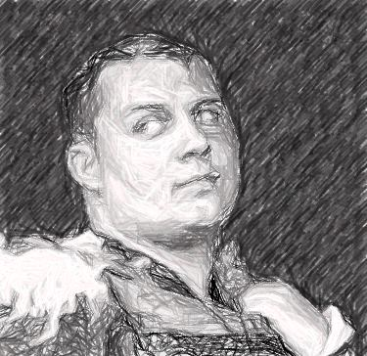
Wanted for theft and mayhem
Distinguishing features: Blind in the left eye; facial scarring around left eye; hands marked with Pallas and Verys
Known associates: Member of the Iron Raptors
Offenses: Theft of forty ingots of tempest jade from Taggart's of Meade; assault and mayhem against the persons of Glen and James Taggart; criminal damage against Taggart's of Meade
Considered armed and dangerous

