
Citadel Guard

Report from XXXXX, The Army of the Citadel, XXXXX
Body Text.
Roll of Honour
This season our forces were supported by troops under the banners of ROLL OF HONOUR

Game Information
The Empire has ….
Your fighting strength has ... and ix now ZZZZZ.
Cyclic Resonance
The army can use the arcane consolidation order when defending, or the onrushing storm order when attacking. The general of the army can be used to focus a ritual targeting the territory where the army is.
Arcane Consolidation
- The army generates mana crystals based on the number of victory points generated.
- Does not change army strength, casualties inflicted or casualties suffered.
The army concentrates on making magical preparations, shoring up their reserves of mana crystals and seeking out nearby sources of magic. A portion of this bounty in the form of mana crystals is passed to the army general so that they can make the most appropriate use of it.
Onrushing Storm (Technique of the Transcendent Claw)
- The army must be attacking a region in a territory containing a named fortification or else the order defaults to cautious advance. The fortification need not be in the region being attacked, and this order will not cause it to be involved directly in the campaign.
- All casualties inflicted by this army are directed at the named fortification.
This order damages and potentially destroys a fortification; it is especially powerful in that it can be used from a distance – the Citadel Guard do not need to engage the fortification and can indeed be involved in a campaign in an entirely different part of the territory.
Ritual targeting
This army contains many specialized magicians and magical experts. The general of the army can serve as a focus for any ritual that targets a territory, replacing the requirement for that ritual to be performed at a regio in the target territory. This only works for rituals targeting the territory where the army is currently on campaign. The general must be present throughout the ritual. Examples of rituals that can be empowered in this way might include Frozen Citadel of Cathan Canae (although the target territory must still contain a suitable region), or a curse such as Rivers Run Red or Naeve's Twisting Blight.


Golden Axe
Golden Axe Report from the XXX, YYYYY
Body Text.
Roll of Honour
This season our forces were supported by troops under the banners of ROLL OF HONOUR

Game Information
The Empire has ….
Following a season of …. your fighting strength has ... and ix now ZZZZZ.
Resilient
You army can take the grinding advance attacking order.
Grinding advance
- Casualties suffered by this army are reduced by three tenths.
- Casualties inflicted by this army are reduced by a fifth.
The army slowly advances, consolidating every gain before moving forward. The army looks to avoid direct engagements with the enemy, ceasing their advance and taking defensive positions if they are engaged.


Valiant Pegasus
Valiant Pegasus report YYYY, XXXX
Body Text.
Roll of Honour
This season our forces were supported by troops under the banners of ROLL OF HONOUR

Game Information
The Empire has ….
Your fighting strength has ... and ix now ZZZZZ.

Siege
Your army can use the storm the walls order when attacking.
Storm the walls
- The army must be attacking a region containing a fortification or else the order defaults to cautious advance
- The ability of this army to capture the fortified region is increased by half
- Casualties suffered by the army are increased by three tenths.
The army unleashes hell against the fortification. While catapults and trebuchet pound the walls, siege towers and ladders are deployed to allow the soldiers to take the fight to the defenders. Meanwhile, engineers work to undermine the walls, and massive covered rams are deployed against the gates. The loss of life is likely to be severe, but the fortification will fall much more quickly than it might in a prolonged siege.

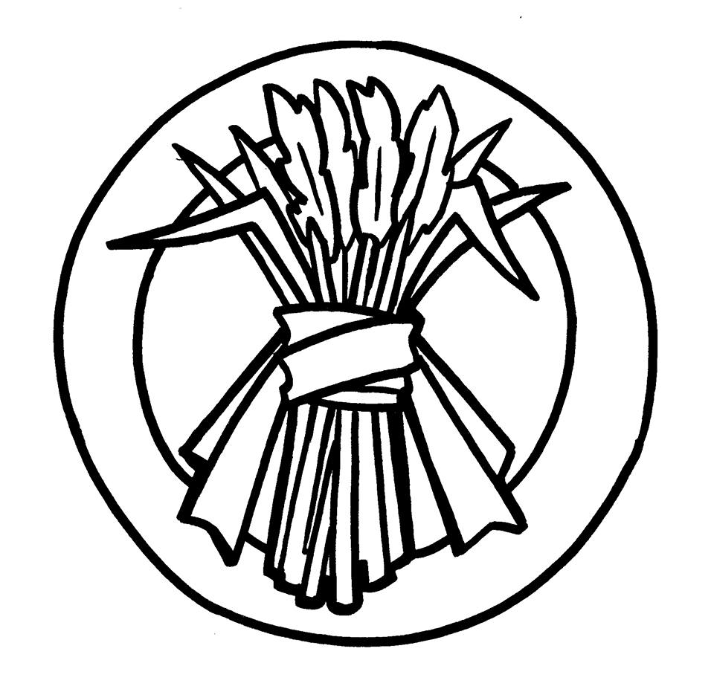
Strong Reeds
(ARMY NAME), (CURRENT LOCATION), (IC SUMMIT)
Body Text.
Roll of Honour
This season our forces were supported by troops under the banners of ROLL OF HONOUR

Game Information
The Empire has ….
Following a season …. our fighting strength has ... and ix now ZZZZZ.
Hard Bitten
You can use the make them pay order when defending.
Make them pay
- Casualties inflicted by this army are increased by two fifths
- Casualties suffered by this army are increased by a fifth
The army attempts to bleed the enemy, making them pay for every inch of ground surrendered. The army takes any chance to butcher their attackers; enemies suffer greatly increased casualties if they push forward, at the price of increased losses for the defenders.


Golden Sun
(ARMY NAME), (CURRENT LOCATION), (IC SUMMIT)
Body Text.
Roll of Honour
This season our forces were supported by troops under the banners of ROLL OF HONOUR

Game Information
The Empire has ….
Following a season …. our fighting strength has ... and ix now ZZZZZ.
Resilient
You army can take the grinding advance attacking order.
Grinding advance
- Casualties suffered by this army are reduced by three tenths.
- Casualties inflicted by this army are reduced by a fifth.
The army slowly advances, consolidating every gain before moving forward. The army looks to avoid direct engagements with the enemy, ceasing their advance and taking defensive positions if they are engaged.


Seventh Wave
(ARMY NAME), (CURRENT LOCATION), (IC SUMMIT)
Body Text.
Roll of Honour
This season our forces were supported by troops under the banners of ROLL OF HONOUR

Game Information
The Empire has ….
Following a season …. our fighting strength has ... and ix now ZZZZZ.

Scouting
- The general who commands the army receives a report about forces present in the same territory as the army
A scouting army is adept at gathering information about opposing forces. While it is active in a territory, associated rangers, agents and magicians gather intelligence about opposing forces in the area. They compose a report specifically for their general which includes information such as details of the campaign armies in the territory; their allegiance; an estimation of their strength; the name of their general; information about their special qualities; significant local fortifications; and other potentially useful strategic and tactical information about the campaign and the forces involved in it. Because this information is gathered by mundane means, and by agents in the field, it is rarely impeded by magical effects such as Drawing the Penumbral Veil.


Summer Storm
(ARMY NAME), (CURRENT LOCATION), (IC SUMMIT)
Body Text.
Roll of Honour
This season our forces were supported by troops under the banners of ROLL OF HONOUR

Game Information
The Empire has ….
Following a season …. our fighting strength has ... and ix now ZZZZZ.

Relentless
Your army can take the cut them down order when attacking.
Cut them down
- Casualties inflicted by this army are increased by three tenths
- Casualties suffered by this army are increased by a fifth
The army takes every opportunity to engage with the enemy to try and cut them down. They may claim some territory, but this is secondary to their goal of slaughtering as many of the enemy as possible. This emphasis on engaging the enemy means that the army loses more troops itself; but the commitment to fighting and preparations it takes mean that it suffers comparatively less than the opponents it engages.


Wolves of War
(ARMY NAME), (CURRENT LOCATION), (IC SUMMIT)
Body Text.
Roll of Honour
This season our forces were supported by troops under the banners of ROLL OF HONOUR

Game Information
The Empire has ….
Following a season …. our fighting strength has ... and ix now ZZZZZ.
OOC NOTE: while you are general of this army you are affected by a powerful roleplaying effect: you are never satisfied with the size, strength, military readiness or agreed tactics of your army, band, nation or Empire; you seek to improve things, doubting the opinions of others and being driven to fine new ways to improve your army and the capacity of the soldiers under your command.

Mercenary
- The army can use siege, scouting, foraging, resilient or skirmishing once each per year.
- Skirmishing and Foraging are not available until after Autumn Equinox 380YE.
A mercenary army is versatile, but can only employ each type of specialist troop once a year. For example, the general of the Wolves of War is appointed in Autumn. They might immediately employ wagon raiders (and use the pillage order), but then cannot employ those auxiliary troops again until after the next Autumn summit.
Enchantment : Bound by Common Cause
The Wolves of War are under the effect of a powerful enchantment ...


Granite Pillar
(ARMY NAME), (CURRENT LOCATION), (IC SUMMIT)
Body Text.
Roll of Honour
This season our forces were supported by troops under the banners of ROLL OF HONOUR

Game Information
The Empire has ….
Following a season …. our fighting strength has ... and ix now ZZZZZ.
Disciplined
Your army can use the strategic defence defending order.
Strategic defence
- The army gains an additional victory point for each enemy army in the territory that takes an attacking order to a maximum of 5 additional victory points.
The strategic army concentrates on orchestrating well planned defences designed to exploit flaws in the enemy strategy. The army excels at taking advantage of the slightest mistake or misjudgement by enemy commanders.


Quiet Step
(ARMY NAME), (CURRENT LOCATION), (IC SUMMIT)
Body Text.
Roll of Honour
This season our forces were supported by troops under the banners of ROLL OF HONOUR

Game Information
The Empire has ….
Following a season …. our fighting strength has ... and ix now ZZZZZ.

Scouting
- The general who commands the army receives a report about forces present in the same territory as the army
A scouting army is adept at gathering information about opposing forces. While it is active in a territory, associated rangers, agents and magicians gather intelligence about opposing forces in the area. They compose a report specifically for their general which includes information such as details of the campaign armies in the territory; their allegiance; an estimation of their strength; the name of their general; information about their special qualities; significant local fortifications; and other potentially useful strategic and tactical information about the campaign and the forces involved in it. Because this information is gathered by mundane means, and by agents in the field, it is rarely impeded by magical effects such as Drawing the Penumbral Veil.


Eastern Sky
(ARMY NAME), (CURRENT LOCATION), (IC SUMMIT)
Body Text.
Roll of Honour
This season our forces were supported by troops under the banners of ROLL OF HONOUR

Game Information
The Empire has ….
Following a season …. our fighting strength has ... and ix now ZZZZZ.
Resourceful
Your army has expert logistical support. The army can benefit from emergency resupply regardless of what territory they are in or whether they are engaged by the enemy. The army can also benefit from natural resupply regardless of what territory they are in as long as they are not engaged by the enemy.

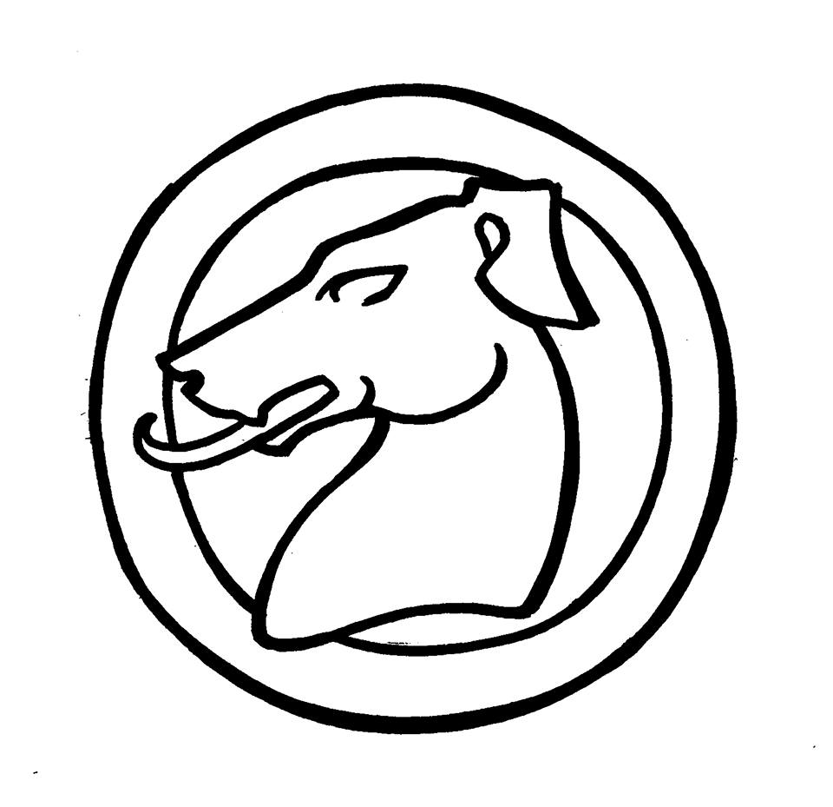
Hounds of Glory
(ARMY NAME), (CURRENT LOCATION), (IC SUMMIT)
Body Text.
Roll of Honour
This season our forces were supported by troops under the banners of ROLL OF HONOUR

Game Information
The Empire has ….
Following a season …. our fighting strength has ... and ix now ZZZZZ.
Glorious
Your army can take the triumphant charge attacking order, or the final stand defensive order.
Triumphant charge
- The ability of this army to capture territory is increased by two-fifths.
- Casualties inflicted by this army are increased by one fifth.
- Casualties suffered by this army are increased by half.
A general who unleashes their troops in a triumphant charge seeks great victory, but pays a great price. The army confronts the strongest enemy troops and the most defended positions, and attempts to rout them. Individual soldiers and companies engage in valiant attacks, employing risky tactics to defeat their opponents. The army will gain much more ground, but does so at the cost of increased casualties.
Final stand
- Any victory gained by the enemy converts to additional casualties taken by this army, rather than territory gained.
- Every enemy victory point causes 100 additional casualties to this army until the army disbands.
Sometimes a general needs to hold a position regardless of cost. A final stand trades Imperial lives for every inch of ground that would otherwise be lost. The order is rarely used; even if the army is not wiped out, it will almost certainly be severely weakened. When an attacking force must not be allowed to gain territory or establish a beachhead, it is incredibly effective.


Red Wind Corsairs
(ARMY NAME), (CURRENT LOCATION), (IC SUMMIT)
Body Text.
Roll of Honour
This season our forces were supported by troops under the banners of ROLL OF HONOUR

Game Information
The Empire has ….
Following a season …. our fighting strength has ... and ix now ZZZZZ.

Foraging
Your army can take the pillage attacking order.
Plunder
- The army generates wealth based on the number of victory points generated.
- Does not change army strength, casualties inflicted or casualties suffered.
- The army does not loot its allies: they must be in hostile territory or facing some enemy opposition to use this order.
The army concentrates on looting enemy forces. They launch attacks intended to capture baggage trains and other financial objectives. They focus on capturing mines, forest preserves, farms, businesses, mana sites and herb gardens. A portion of this bounty in the form of money, herbs, crystal mana, crafting materials and potentially even rare materials such as weirwood, mithril or white granite are claimed by the army general.

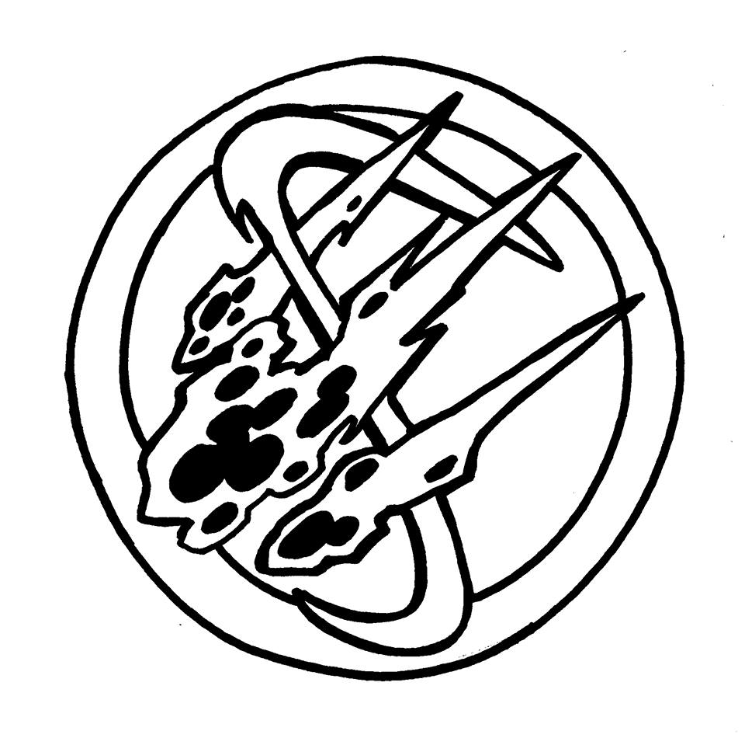
Fire of the South
(ARMY NAME), (CURRENT LOCATION), (IC SUMMIT)
Body Text.
Roll of Honour
This season our forces were supported by troops under the banners of ROLL OF HONOUR

Game Information
The Empire has ….
Following a season …. our fighting strength has ... and ix now ZZZZZ.
Fast
Your army can move as far as you wish each season. It must still stop moving when it enters a hostile territory. Within the Empire, a fast army takes advantage of the trods whenever it can, supplementing their magic with forced marches and expertly organised baggage trains.


Winter Sun
(ARMY NAME), (CURRENT LOCATION), (IC SUMMIT)
Body Text.
Roll of Honour
This season our forces were supported by troops under the banners of ROLL OF HONOUR

Game Information
The Empire has ….
Following a season …. our fighting strength has ... and ix now ZZZZZ.
Guerilla
You can take the hit and run order when defending.
Hit and run
- Your side must control a region with the forested, hilly or marsh keyword.
- The ability of this army to defend territory is increased by a fifth.
- Casualties suffered by this army are decreased by a fifth.
- Casualties inflicted by this army are decreased by a fifth.
The army uses their mastery of wilderness survival to impede enemy advances. They set up camp in defensible locations, use hidden paths to move around, and employ natural features of the wilderness to hamper their attackers. A guerilla army in a defensible position does everything it can to make itself hard to attack, rarely presenting the enemy with an opportunity for a pitched battle. This tactic is especially effective at slowing the advance of an enemy force waiting for reinforcements.


Green Shields
(ARMY NAME), (CURRENT LOCATION), (IC SUMMIT)
Body Text.
Roll of Honour
This season our forces were supported by troops under the banners of ROLL OF HONOUR

Game Information
The Empire has ….
Following a season …. our fighting strength has ... and ix now ZZZZZ.
Glorious
Your army can take the triumphant charge attacking order, or the final stand defensive order.
Triumphant charge
- The ability of this army to capture territory is increased by two-fifths.
- Casualties inflicted by this army are increased by one fifth.
- Casualties suffered by this army are increased by half.
A general who unleashes their troops in a triumphant charge seeks great victory, but pays a great price. The army confronts the strongest enemy troops and the most defended positions, and attempts to rout them. Individual soldiers and companies engage in valiant attacks, employing risky tactics to defeat their opponents. The army will gain much more ground, but does so at the cost of increased casualties.
Final stand
- Any victory gained by the enemy converts to additional casualties taken by this army, rather than territory gained.
- Every enemy victory point causes 100 additional casualties to this army until the army disbands.
Sometimes a general needs to hold a position regardless of cost. A final stand trades Imperial lives for every inch of ground that would otherwise be lost. The order is rarely used; even if the army is not wiped out, it will almost certainly be severely weakened. When an attacking force must not be allowed to gain territory or establish a beachhead, it is incredibly effective.


Northern Eagle
(ARMY NAME), (CURRENT LOCATION), (IC SUMMIT)
Body Text.
Roll of Honour
This season our forces were supported by troops under the banners of ROLL OF HONOUR

Game Information
The Empire has ….
Following a season …. our fighting strength has ... and ix now ZZZZZ.
Guerilla
You can take the hit and run order when defending.
Hit and run
- Your side must control a region with the forested, hilly or marsh keyword.
- The ability of this army to defend territory is increased by a fifth.
- Casualties suffered by this army are decreased by a fifth.
- Casualties inflicted by this army are decreased by a fifth.
The army uses their mastery of wilderness survival to impede enemy advances. They set up camp in defensible locations, use hidden paths to move around, and employ natural features of the wilderness to hamper their attackers. A guerilla army in a defensible position does everything it can to make itself hard to attack, rarely presenting the enemy with an opportunity for a pitched battle. This tactic is especially effective at slowing the advance of an enemy force while awaiting reinforcements.


The Tusks
(ARMY NAME), (CURRENT LOCATION), (IC SUMMIT)
Body Text.
Roll of Honour
This season our forces were supported by troops under the banners of ROLL OF HONOUR

Game Information
The Empire has ….
Following a season …. our fighting strength has ... and ix now ZZZZZ.
Disciplined
Your army can use the strategic defence defending order.
Strategic defence
- The army gains an additional victory point for each enemy army in the territory that takes an attacking order to a maximum of 5 additional victory points.
The strategic army concentrates on orchestrating well planned defences designed to exploit flaws in the enemy strategy. The army excels at taking advantage of the slightest mistake or misjudgement by enemy commanders.

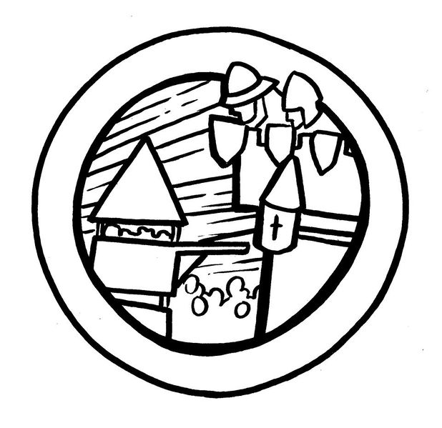
Towerjacks
(ARMY NAME), (CURRENT LOCATION), (IC SUMMIT)
Body Text.
Roll of Honour
This season our forces were supported by troops under the banners of ROLL OF HONOUR

Game Information
The Empire has ….
Following a season …. our fighting strength has ... and ix now ZZZZZ.

Siege
Your army can use the storm the walls order when attacking.
Storm the walls
- The army must be attacking a region containing a fortification or else the order defaults to cautious advance
- The ability of this army to capture the fortified region is increased by half
- Casualties suffered by the army are increased by three tenths.
The army unleashes hell against the fortification. While catapults and trebuchet pound the walls, siege towers and ladders are deployed to allow the soldiers to take the fight to the defenders. Meanwhile, engineers work to undermine the walls, and massive covered rams are deployed against the gates. The loss of life is likely to be severe, but the fortification will fall much more quickly than it might in a prolonged siege.

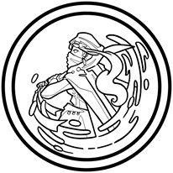
Freeborn Storm
(ARMY NAME), (CURRENT LOCATION), (IC SUMMIT)
Body Text.
Roll of Honour
This season our forces were supported by troops under the banners of ROLL OF HONOUR

Game Information
The Empire has ….
Following a season …. our fighting strength has ... and ix now ZZZZZ.

Navy
The Freeborn Storm is a navy rather than an army. A summary of available Naval orders follows here.

Offensive Maritime Orders
- All maritime orders cause the navy to intercept any opposing navy that is attempting to move past them
- Maritime orders cause a naval campaign to take place in the territory if there are any opposing navies
- The winning force will inflict extra casualties on the losing force
Maritime offensive orders cause a navy to attack opposing navies that are present in the territory. If an opposing navy attempts to move through the territorial waters during that season they will be forced to stop and be engaged by the navy with offensive maritime orders.
These orders initiate a maritime campaign in the territory if there is an opposing navy present. If there is no navy present in the territory during the campaign, then the navy has no effect.
Maritime campaigns are fought to sink and destroy the enemy navy, not for control of territory. There is no territory to capture at sea, so there is no calculation of victory points in a maritime campaign.

Naval Engagement
- Most effective against navies with harry shipping or shore offensive orders
- Least effective against navies with naval support or defend the coast orders
If there are other navies present in the territory, then the admiral may order the force to engage them. A naval engagement is only effective if there is an opposing navy present in the territory at any time during the season, otherwise the navy has no effect that season.
A naval engagement is particularly effective against opposing navies on harry shipping or shore offensive orders. The casualties inflicted on opposing navies with these orders are increased by three tenths.
A naval engagement is less effective against opposing navies on defend the coast or naval support orders. The casualties inflicted on opposing navies with these orders are decreased by three tenths.

Harry Shipping
- Most effective against navies with naval support, defend the coast or shore offensive orders
- Least effective against navies with naval engagement orders
If there are opposing navies present in the territory, the admiral may order their fleet to harry their shipping. The navy will disperse throughout the territory attempting to hunt down and sink enemy vessels operating in the area. This order is only effective if there is an opposing navy present in the territory at any time during the season, otherwise the navy has no effect that season.
Harry shipping is particularly effective against opposing navies on naval support, defend the coast, or shore offensive orders. The casualties inflicted on opposing navies with these orders are increased by three tenths.
Harry shipping is less effective against opposing navies on naval engagement orders. The casualties inflicted on opposing navies with this order are decreased by three tenths.

Offensive Coastal Orders
- An Imperial navy can attack any region that has the coastal keyword
A navy can attack any region that has the coastal keyword, provided it can reach the territory. Imperial navies can attack a region even if it is not adjacent to an existing region controlled by the Empire, but in this case it is twice as difficult to take the region.

Shore Offensive
- Vulnerable to opposing navies with offensive maritime orders
Regardless of whether the navy directly assaults coastal towns and ports, or attempt to sneak marines ashore on empty beaches, a shore offensive is always a risky strategy. If the navy is attacked by opposing forces then they will suffer grievous casualties in the assault.
A navy that is engaged in a shore offensive can only capture coastal regions. If there are no legitimate targets for the navy to attack, then this order reverts to naval support if possible.
If an attacking force is victorious - they will capture land - the greater the victory the more land they will take in a season.

Defensive Coastal Orders
- No campaign will take place unless another force issues an order to attack
- A defensive coastal order may only be given by a side that controls a coastal region
Navies may attack other navies at sea, but they cannot attempt to defend the open waters. However they may take a defensive position either providing support and logistics to allied armies engaged in a land campaign, or by committing themselves to the defense of coastal regions, or by putting to port to avoid a conflict with an opposing navy.
If the defenders are victorious - if their side has a higher effective strength than the attacker, then their victory translates directly into reduced casualties for the defenders. The greater the victory, the less casualties they suffer. Defenders take fewer casualties than attackers anyway; all other factors being equal there is a small natural advantage that favours the defender.

Naval Support
- Helps achieve victory in a land campaign, but does not inflict or suffer casualties in that campaign
- Most vulnerable to navies with harry shipping orders
- Least vulnerable to navies with naval engagement orders
If there are other Imperial armies present in the territory, the admiral may order a navy to provide them with support. The navy will not initiate a campaign by providing naval support, and does not directly engage the enemy, but it will provide highly effective support to land based armies in the territory, granting them improved logistics and supply lines.
A force on naval support orders contributes its full strength to determine the scale of victory of any land campaign that takes place in the territory. The navy does not take or cause any casualties from this campaign.
If the navy is attacked by an opposing navy with offensive maritime orders then it will also participate in the ensuing sea campaign.
If there are attacks on all friendly regions with the coastal keyword by opposing forces then this order reverts to defend the coast.

Defend the Coast
- Orders the navy to participate in a land campaign to defend coastal regions
- Any victory achieved by the navy translates into fewer casualties incurred rather than territory gained
- Most vulnerable to navies with harry shipping orders
- Least vulnerable to navies with naval engagement orders
If there are opposing armies attacking coastal regions in the territory, then the admiral may commit the navy to defend the coastline. The navy will move close to the shore and attempt to engage enemy land forces directly. The navy plays a full part in the ensuing land campaign and takes casualties from it as normal.
If the navy is attacked by an opposing navy with offensive maritime orders then it will also participate in the ensuing sea campaign.
If there are no attacks on regions with the coastal keyword then this order reverts to naval support.

Put to Port
- Orders the navy to put port, tying up vessels at wharfs and quays at a friendly shipyard
- The navy cannot be attacked by opposing navies and does not participate in any military campaigns
- Natural resupply is increased by 20% while a navy is in port at a shipyard
If there is an unoccupied shipyard controlled by an ally in a territory, then an admiral may order their navy to put to port. If the vessels reach the port unimpeded then they can dock safely and take no further part in any military campaigns taking place that season. They cannot defend the area and do not take casualties from any opposing navies on offensive maritime orders while they remain in port.
Natural resupply increases by 20% while a navy is in port. If the region containing a shipyard is conquered by an enemy army or navy while a navy is in port, then all the vessels are scuppered and the navy is automatically destroyed.
Only one navy may occupy a shipyard at a time. If two navies attempt to put into a port, the berths will be occupied by the first navy to reach it. A navy remains in port until it issues new orders in a following season. If a navy cannot reach the safety of a port then this order reverts to defend the coast if possible.


Black Thorns
(ARMY NAME), (CURRENT LOCATION), (IC SUMMIT)
Body Text.
Roll of Honour
This season our forces were supported by troops under the banners of ROLL OF HONOUR

Game Information
The Empire has ….
Following a season …. our fighting strength has ... and ix now ZZZZZ.
Fast
Your army can move as far as you wish each season. It must still stop moving when it enters a hostile territory. Within the Empire, a fast army takes advantage of the trods whenever it can, supplementing their magic with forced marches and expertly organised baggage trains.

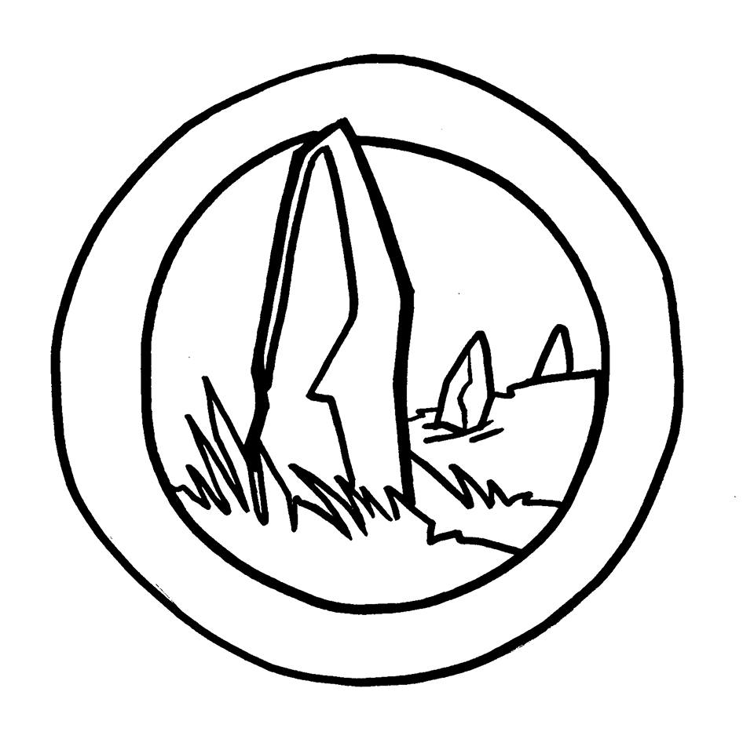
Bounders
(ARMY NAME), (CURRENT LOCATION), (IC SUMMIT)
Body Text.
Roll of Honour
This season our forces were supported by troops under the banners of ROLL OF HONOUR

Game Information
The Empire has ….
Following a season …. our fighting strength has ... and ix now ZZZZZ.
Relentless
Your army can take the cut them down order when attacking.
Cut them down
- Casualties inflicted by this army are increased by three tenths
- Casualties suffered by this army are increased by a fifth
The army takes every opportunity to engage with the enemy to try and cut them down. They may claim some territory, but this is secondary to their goal of slaughtering as many of the enemy as possible. This emphasis on engaging the enemy means that the army loses more troops itself; but the commitment to fighting and preparations it takes mean that it suffers comparatively less than the opponents it engages.


Fist of the Mountain
(ARMY NAME), (CURRENT LOCATION), (IC SUMMIT)
Body Text.
Roll of Honour
This season our forces were supported by troops under the banners of ROLL OF HONOUR

Game Information
The Empire has ….
Following a season …. our fighting strength has ... and ix now ZZZZZ.
Hard Bitten
You can use the make them pay order when defending.
Make them pay
- Casualties inflicted by this army are increased by two fifths
- Casualties suffered by this army are increased by a fifth
The army attempts to bleed the enemy, making them pay for every inch of ground surrendered. The army takes any chance to butcher their attackers; enemies suffer greatly increased casualties if they push forward, at the price of increased losses for the defenders.

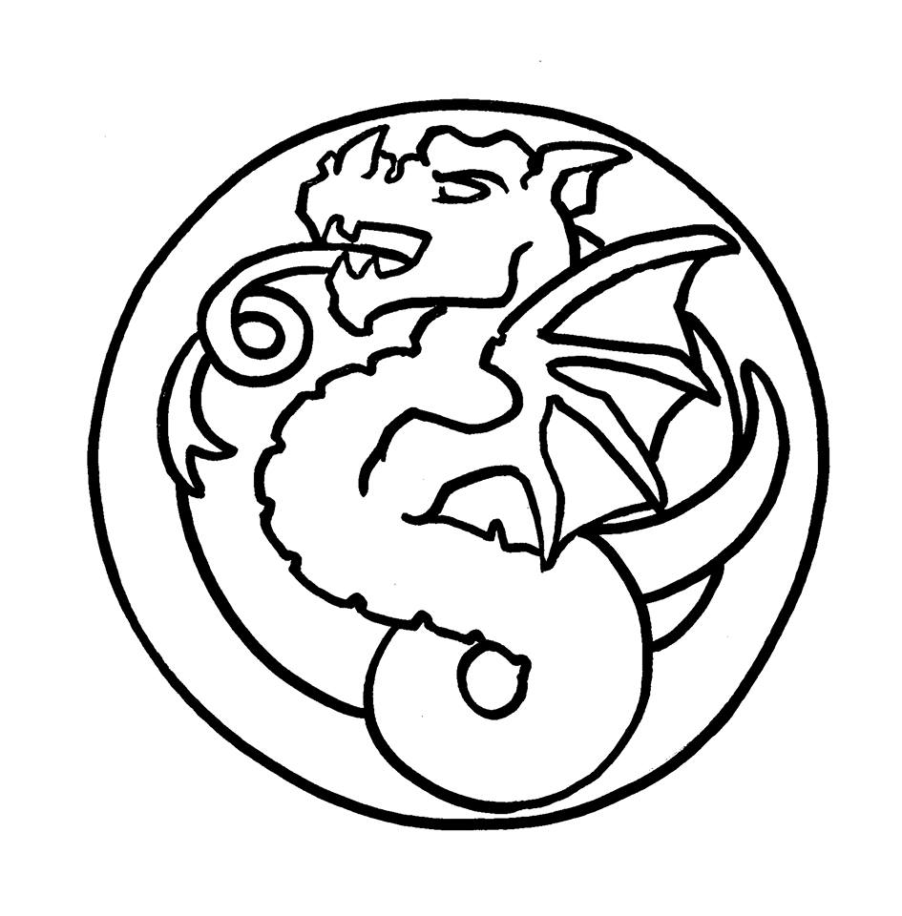
Drakes
(ARMY NAME), (CURRENT LOCATION), (IC SUMMIT)
Body Text.
Roll of Honour
This season our forces were supported by troops under the banners of ROLL OF HONOUR

Game Information
The Empire has ….
Following a season …. our fighting strength has ... and ix now ZZZZZ.

Resourceful
Your army has expert logistical support. The army can benefit from emergency resupply regardless of what territory they are in or whether they are engaged by the enemy. The army can also benefit from natural resupply regardless of what territory they are in as long as they are not engaged by the enemy.


Gryphon's Pride
(ARMY NAME), (CURRENT LOCATION), (IC SUMMIT)
Body Text.
Roll of Honour
This season our forces were supported by troops under the banners of ROLL OF HONOUR

Game Information
The Empire has ….
Following a season …. our fighting strength has ... and ix now ZZZZZ.
Conquering
A conquering army focuses on capturing territory, driving the defenders of the land before them. You can choose to take the glorious conquest order while attacking.
Glorious Conquest
- The ability of this army to conquer territory is increased by ...
The army seeks to dominate key strategic objectives, and focuses on claiming territory from the opposing army.

