Imperial Book of the Exorcist.

By
Inquisitor Greta of Felixs Watch



It is the Wisdom and the Courage that is needed to deal with unquiet spirits and ghost i will write of here. My own experience and tactic, some examples of those things and the tricks they employee in the dark games they play. May Virtue and these words guide you in your endeavours against these creatures of corrupted virtue.

On the nature of spirits and the spiritual malfeasant forces and their awareness of the living.

Of those spirits we can reduce them into two camps. The self-aware spirit and the unaware or 'drone' spirit. Of the two I will speak of the latter first.
The Unaware, or as I will hence for describe as drone, spirit is often a week entity that is easy to exorcise. The often repeat an act over and over like an actor in one of those dull league plays without mind to anything else. Only when interrupted do they tend to register the other people and even then their interactions tend to be monotonous and without head to you or any others, they tend to drone on about their death, circumstance or anything to do with the act they are stuck in doing. Not unlike talking to an Urzien magus. Often Exorcism is unneeded and simply fulfilling what these poor wretches need to allow them to move on is enough to lay them to rest and allow their spirits to travel on to the labyrinth. A special mention goes to wraiths. Although technically self-aware, many are so focused on the violence and horror they wish to visit on others that in many ways they are drones. They have no existence outside the terror they with to sow that they become a mocking parody of the person they once were, it is an act of the highest loyalty to exorcise these creature so that they may be reborn to rejoin the path of virtue.
Sentient spirits are far more dangerous and insidious. Some yes are horrified by their existence and seek to be sent on their way, however most either actively sought immortality in this form or are so far gone they no longer remember who they once were and now embody false virtues and alien philosophies so apart from humanity they are incomprehensible.
We do not know why some spirits are self aware or not, however age does not seem to be a factor nor how they died. I myself believe that it is to do with the strength of a persons will and that many of the spirits that are self aware chose this path seems to support this. It could also be that the less aware are partly in the labyrinth or even acting like a past life vision, while the self aware are fully in the world of the living. However conjecture, much like asking to borrow sugar from the Brass Coast, is pointless so I will wait for evidence.

Upon the nature and sorts of spirits or a catalogue of sinners.

- Ghosts

This category I fill with those beings with works undone, deaths most tragic or presences most unwelcome within your home.
First of all you can forget those Varuskan stories of Ghosts walking through walls and swords passing through the, A ghost, when manifested has a physical body. Destroying the body however will not lay it to rest, and the ghost will just return. This can buy you breathing room though to work out the best approach for dispatching it. Bare in mind that any object a ghost might carry is also made of this 'ghost stuff' and will fade when away from the ghost itself. The ghost of a sword is still just a ghost.
Ghosts tend to be very focused. They will, as discussed earlier in this work, be charactures of the person they once were. They will focus on a thing, a thing that if resolved will often send them onto the labyrinth. Do not think you can dissuade a ghost from its purpose with mere words. If the ghost is not dangerous I would recommend fulfilling its goals, if it is a menace however exorcism is the way forward. They cannot all talk, some are able only to groan, while others may not even be able to acknowledge the existence of others
Like most spiritual dangers, ghosts often have anchors. Although I will discuss these further and in more detail it is important to note that these object to which the ghost is tied to allow you to attack it with exorcism. To destroy the ghost utterly you must however destroy these anchors.
- Wraiths

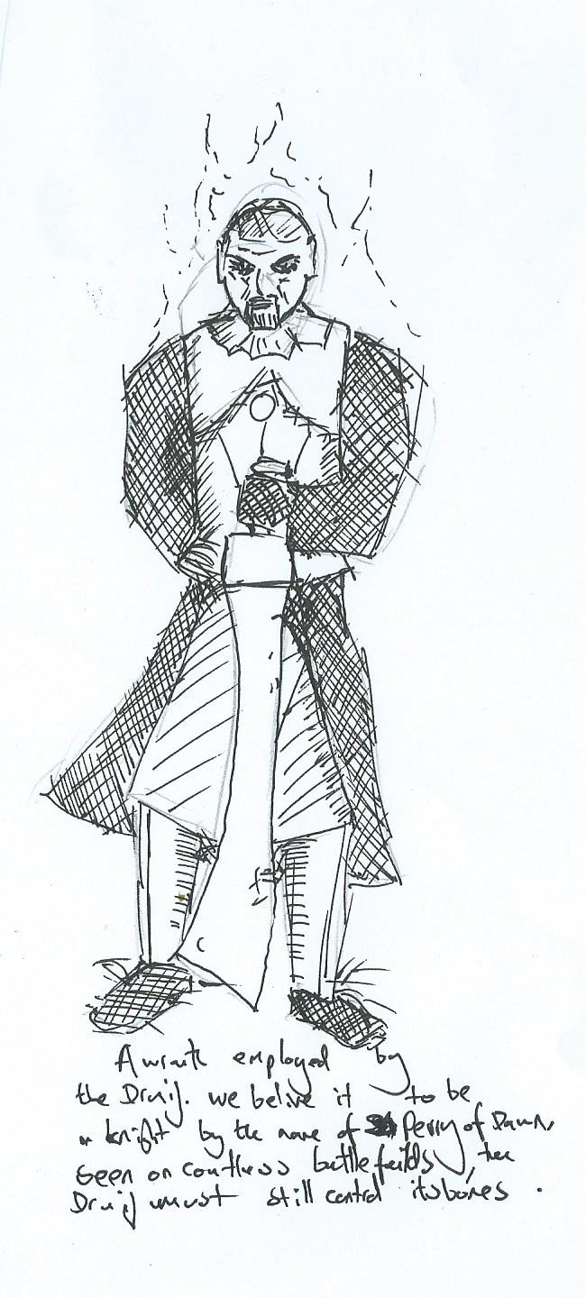
These creatures are very dangerous. Made by fell arts, they are inhuman murderous spirits who's corporal form is far tough than some spirit obsessed with lost love. These monsters, for that is the only word to describe them are deadly and almost unstoppable. When put down they quickly reknit their forms and will attack again, exorcism is the only recourse when dealing creatures such as these.
Often their only anchor is the body they had in mortal life and is often kept by the deviant who creating them.

- The Unnamed.

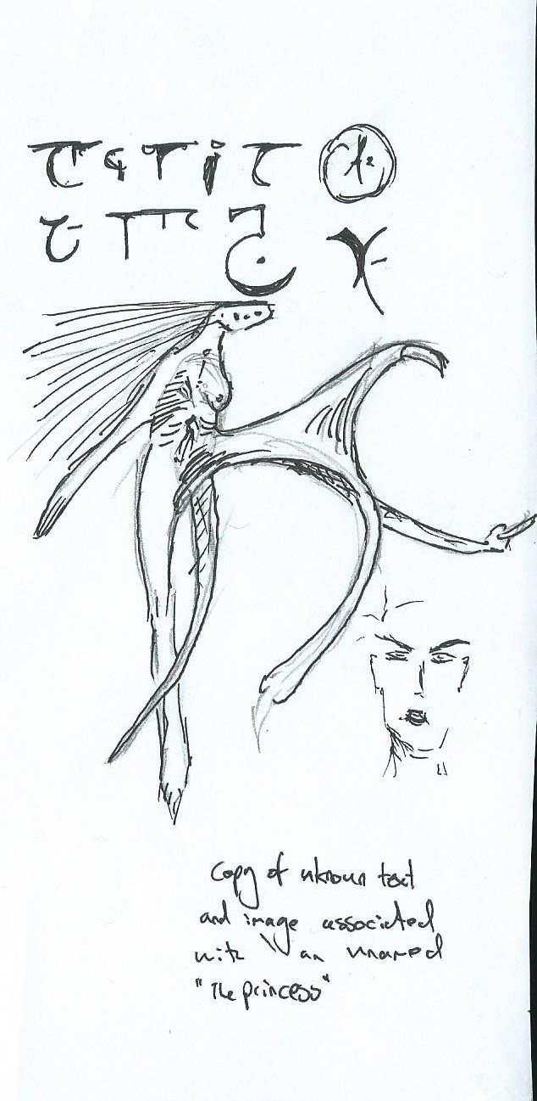
I have not come across many of these creatures. The Unnamed or Spectres are intelligent and seem to embody false virtue. We do not know why they do not have real names, but they go by monikers like 'The Eater of Hope' or 'The Blinded Princess'. They seem to have strange agendas tied to their personalities, often agendas that spread their strange philosophies and unvirtuous ideals. Their spiritual corpus is very tough, however their sentience and vicious alien mindsets are what sets them apart from a Ghost. They have even been known to deal with the living in exchange for services they have, it is rumoured, the power to grant favours to followers or simply those that are willing to meet their price.
They tend to have many anchors and even pay handsomely for the creation of new ones. How this is done I believe is known to accursed Axos and when we finally put that nest of evil and sin to the torch I will sleep better at night.

Anchors, the ties that bind

A ghost or spirit does not need to be anchored to anything, however it is an easy thing to send them to the labyrinth than those without them.
Anchors allow a spirit safe refuge when exorcised. They can return to them to gather strength. To send a spirit on that has anchors you must exorcise those anchors first.
Often these anchors also have unnatural auras or hallowings of false virtue to contend with and can infect others that come in contact with them. I have in the past come across cults to false virtue that have sprung into existence upon discovering the Anchor of some damned spirit having being infected by it. In some cases placing it on an Altar! I would suggest be wary of such things and destroy them where you can.
A spirit can also anchor to places and people, the ghost that haunts a loved one, the castle with the ghostly garrison or the haunted gallows are examples of this. Just as with an object they can be accompanied with false virtue or be influenced by the false virtues of a spirit tied to them.
In all cases often a spirit will attempt to defend the destruction of its anchor in some way if it is alert to what is happening.
Remember also the use of the rite of insight upon an Anchor can show information about a spirit, other anchors and allow you to attack the spirit via exorcism.
It is rumoured that Axos can create new anchors for spirits, that some spirits reward those that create new anchors for them and that some even offer themselves up as anchors. We should burn that nation from the world.

On those Priestly rites and their use in the combating of the unquiet spirit

Of course the most important rite is the rite of exorcism when facing an unquiet sprit so that you can send it on to the labyrinth, however the other rites are just as important.
- Consecration

The use of concentration is very important, but so is research. When tackling a spirit consecrating the ground around you can weaken and disorientate it, even more so if you know the virtue you are representing is in opposition to the spirit in question. However this is not just for tackling dangerous spirits. Some spirits are those of the virtuous and by using Consecrations of Wisdom you can make a spirits see the sense in moving on or Loyalty to stop it from attacking imperial citizens by reminding it of its past.
One last point is that if you must use the profane ritual whispers through the black gate. I would suggest it be only carried out by a Magister and that consecrations are used on the Regio as a matter of course before starting the ritual.
- Anointing
As a warrior dons her harness, so must the priest don their armour. By anointing you will protect your self from the evil effects of some creatures, the more dangerous the creature the stronger you should make your anointing. Often it is useful to have the Wisdom or Courage to face such things and in armouring yourself you make sure you cannot be swayed from your duty by the evil influences such creatures can place upon you. This is very important in the case of Spectres. The Nameless often have strong links to false virtues that may use to try and corrupt you.
- Hallowings

Everything that applies to annoitings applies to Hallowings. It always worries me that True Laio is always used primarily for visions. By creating Relics of the faith that anyone can wield and having the time to create very powerful hallowings means that the tools of the exorcist can protect them against the greatest evils and be reused.
- Insight

This is a very important rite, the ability to see how powerful a spirit is, any testimonies on its soul and find out what anchors it in the world can make the difference between success or failure. I have always felt that any priest who does not know this rite should be censured, however the greater assembly has so far blocked this from becoming religious law.
In using all of the rites together, with strong sects that are able to use laio together to powerful effect can dangerous spirits be sent on to the labyrinth safely. The idea of the lone exorcist facing down unfathomable evils is a fable of Dawnish fantasy.

The Bell, the book and the Icon. The tools of Virtue
There are Four main styles of tool that we use when we confront the unholy and damned.
- Icons.

These lend the aid of the artisan to be able to use a rite. In my humble opinion no member of the synod should rely on these going into a confrontation with a being of broken virtue such as a spirit, however it is useful for other members of a sect who may not have mastered all of the rites, especially exorcism, to be able to lend the power of their virtue to a rite.

- Musical instruments

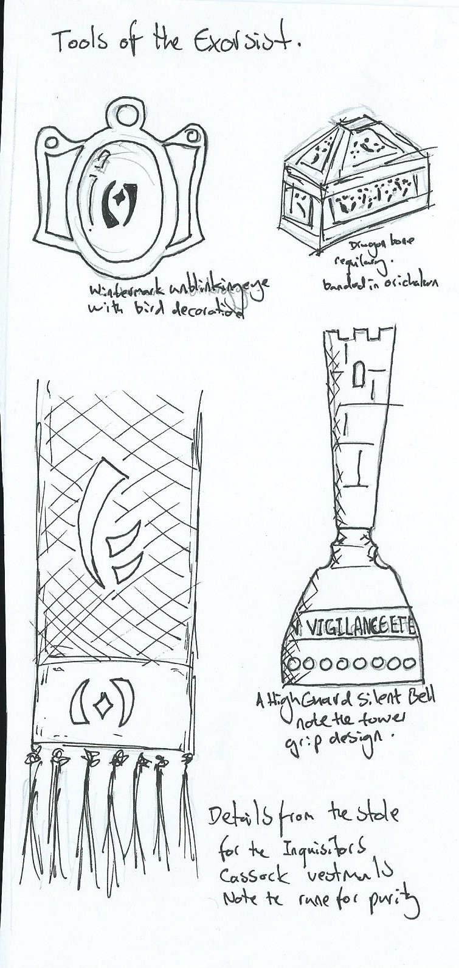
Much as I loath the sound of any music other than the bell or the choir, these tools can be used in a pinch to either allow members of other virtue assemblies to be able to aid you with their virtue or even be able to aid you in being able to create virtuous rites from assemblies not of your own, tailored to fight the creature in front of you. Just remember that a Magister is useful within your Sect so that you may freely avail yourself of these tools quickly and efficiently.
- Vestments.

Of all the vestments a few are of note for their use in combating creatures of the dark. First of all the Inquisitors Cassock allows you to quickly assess suspected anchors, the spirit itself and other factors without eating into your laio reserves. This is important and i should not have to explain why. After that the Splendid Vestment is useful to add punch to a Rite.
- Regalia.

The most obvious and useful of the regalia is the Silent Bell, this combined with the Splendid Vestments are my personal choice when i begin the rite of exorcism after I have done my investigation. After that the Unblinking Eye is a tool I use during my investigations.

- Reliquaries.

I would never hunt alone. My Sect uses a Dragonbone Reliquary. This allows for more power when using Rites, important when girding for battle against the profane and evil.
Remember though these tools are only tools. Only virtue can carry the day against such dread foes.

Ghost stories
In the following part of this tome i collect some ghost stories. Some are reports such as my time in Tessato, others are folk lore and stories of Hearth magic related Ghosts. I have not investigated all of them, but it is to illustrate that we have Ghost stories for a reason in our differing cultures, but also some of these stories I feel could do with investigation. I did not do this alone and I am indebted to the chapters of Highguard, the Imperial Orcs, the Navarr and the people of Varushka in particular for helping compile these stories. Many of whom also helped me in the various battles with the inhuman filth that haunts our lands.

The Maggs Green Ghost
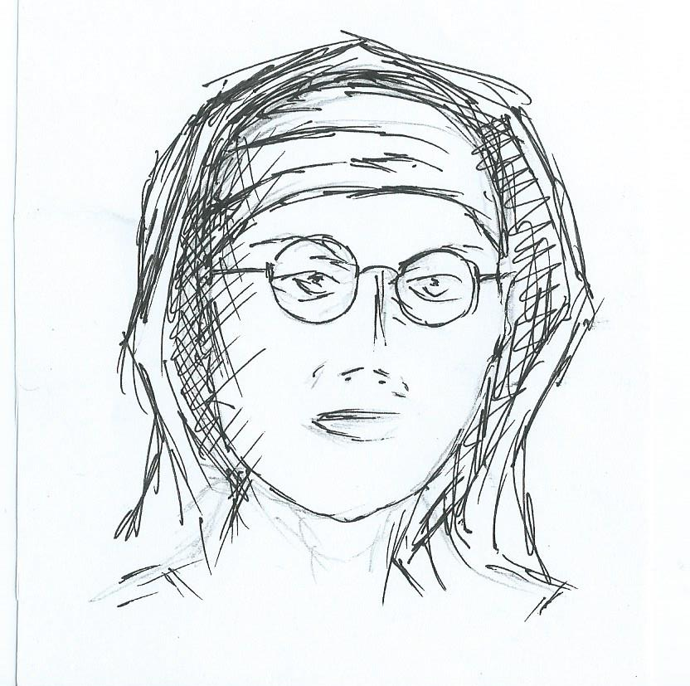
On the Maiden Downs in Mitwold is a farm by the name of Maggs Green. A hundred years ago it was a home to farmer and his wife. They were scorned by villagers as it was believed the wife regularly watered down the milk and cheated her customers by changing the weights on their cheese and butter in a sin against prosperity. It was also believed that she used sorcery to conspire with false gods and spirits.
Eventually as with all things she died, and a while later the villagers saw an apparition on Swallowfield lane. The figure of the wife would walk down the road, wringing its hands chanting in a hollow voice 'Weights and measures I never gave; Milk and water sold never!'. It would then walk to the local pond and sink.
The villagers sent for priests of the Way and the assembly of Prosperity came with a boulder dug from good Marcher earth on a cart. They chanted and used various rites on the stone and lowered it to the bottom of the pond and the ghost was never seen again.
It was later I passed through this village when the pond was being cleared some young workers and they asked how best to move the stone that an older lady from the village told them this story which i have penned here.

The Loud ghosts of Wayford
As well as the legend of Jack-In-Chains it is is said there are also ghosts prowling the area. Shortly after the Marchers was settled it is said that the local Steward of Wayford was abusing his power and using local thugs to keep control.
The locals organised themselves and approached the home of the Steward with loud music for four nights, on the fifth night he ordered the thugs to attack killing some of the local farmers. Eventually the Steward was removed, but on the anniversary of this tragedy every year a spectral crowd banging pots and pans walks the road from market town to the site of the old Stewards house.
Exorcists have been unable to get rid of the Ghosts and believe that it is because there is still an anchor they cannot find.

The eleven drowned sons of Varushka
Once there was a powerful boyar. He married a fair schlacta who loved him beyond measure. They had many happy years together, and she bore eleven strong sons.
Time passed. His wife's hair greyed and her skin became wrinkled. The boyar began to loose interest and his eyes often fell upon the beautiful young stenza who filled his halls with music and song, and told fine stories to his sons. One summer night, the boyar resolved to be rid of his wife. As she slept, he pressed a pillow over his wife's face until she was dead. Then he carried her body to village carp pond, weighed it down with stones, and tossed it where the water was deepest.
The next day, when he was asked where his wife was to be found, he replied that she had travelled to visit her niece in Temeschwar. A month passed, and the boyar told his sons and the village wise ones that word had come from Temeschwar that his wife had been taken by wolves as she travelled.
For most of a year, the boyar and his sons mourned. Then, the boyar began to turn his attention once more to the beautiful stenza. So charming was he that she soon fell in love. On the anniversary of his first wife's murder, the boyar and the stenza were wed.
As the years passed tragedy began to strike the family. One by one, each of the boyar's eleven sons met with mysterious deaths; each one drowned in the carp pond. Sometimes bodies were found floating in the pond in the morning, and wet footprints were found leading into their bedrooms. Eerie singing was heard in the night before a death, seeming to call the boys by name. Other times, unexplained accidents occurred near the pond. One son slipped on the stones near the shore and the weeds seemed to pull him down until he drowned. No blame could be laid at the foot of any living person in the village for any of the deaths. With each tragedy, the Wise Ones declared that the pond was bad luck and begged the boyar to have it drained. Each time he refused, claiming that the village depended upon the carp within it (and wishing to keep his secret hidden).
Then, one day while the boyar was out hunting wolves in the forest, his last and youngest son met his end in the pond. His friends told their parents that the boy had said he'd seen a woman struggling in the water and dived in to save her. Not one of the others has seen the woman, and they had been unable to save the boy before he drowned. Beset with grief, for she had come to love the boys as a mother, the stenza ordered the pond drained.
With the pond drained, the body of the boyar's first wife was discovered and his lie made plain. When the boyar returned from his hunt, the villagers gathered, and the Wise Ones ordered him drowned for his crime.
The beautiful stenza was named boyar of the vale. In time, she remarried. It is said that her children became the Vodyani of Varushka. The spirits of the boyar's eleven sons were trapped forever; you can see them shining in the night as the eleven stars of the the Drowned Man.

The Waste-Walker
Last winter, in Olodny, I met a trapper; a thin and sallow man with the reddest hair I've ever seen. He claimed to have travelled down from the Northern Wastes through Pakaanan's Pass and into Meikarova. After black bread and salt, we drank strong spirits, ice-cold from frosted cups. The trapper told how he, his wife, and their daughter had been captured by Thule raiders and taken north, through mountain passes, towards Otkodov where the Dragons rule.
The trapper spun a tale of how, in the dark of night, as the snow fell lightly upon the camp of the raiders, a distant howl, as of something long lost and forgotten, echoed through the pass and then fell silent. Hearing this, the Thule roused themselves and, with fearful eyes and hushed words, piled the fire high and took up swords and spears. Throughout the night the snow fell, heavier and heavier. With the snow came mist and fog, and the Thule drew together, facing outward into the night and clutching their spear-shafts tightly.
Towards dawn the snowfall ceased and the fog thinned. When the day came, the Thule discovered that one of their warriors was missing, and the camp was ringed with bloody footprints. That day, the party marched hard and fast, their captives beaten if they slowed. Few words were spoken, and many a backward glance was cast.
As dusk fell on the second night, the howl was heard again, closer than before, and somehow sounding almost eager. Once more the fog drew in and the snow fell hard. The Thule pressed on in haste, forgoing camp in favour of clearing the pass. The very darkness seemed to press upon them, the fog clung like ghostly fingers tugging at their sleeves and the snow dragged at their feet. The Thule, hardened warriors each, looked close to panic and hurried harder. From the depths of the fog each man and woman present fancied they heard their name called faintly upon the wind.
Exhausted the trapper's daughter stumbled and fell to the ground. When he and his wife stopped to drag her up, the trapper told me that the Thule simply left them there and pushed on into the blizzard. The family held together until the dawn came, sheltered in the lee of a tall stone beside the path, listening for the howl, but hearing only the wind and their own fearful sobbing.
In the light, the family saw that the stone which had sheltered them through the night was carved with ancient Ushkan symbols of the virtues. With grateful hearts the family trudged back towards Varushka. After two days of trekking they came upon a patch of blood-smeared snow and the remains of one of the Thule; its bones gnawed and stripped of flesh, but its pack untouched and its spear-tip unbloodied.
The Thule's supplies sustained the family until they once more crossed into the lands of the Empire; safe, but haunted by the memories of their ordeal. Unwilling to return to the cottage where they had been captured, the trapper and his family moved to a vale in Karsk and settled there.
With his tale told, I thanked the trapper and, gifting him a charm to ward off evil, I took my leave. In the spring, I headed out towards Pakaanan's Pass, seeking to lend aid to the military campaign in Skarsind. In the foothills of the mountains, I stopped to rest and picnic in a grove of pines. While I ate, the sun rose high in the sky, melting the winter snows and revealing the ground beneath. It was then that I spied the bones where snow had been. They were cracked and splintered, sucked dry of marrow and marked with many knife cuts. Two sets of bones there were – two spring snowdrops - those of an adult and a child, and clad in torn Varushkan dresses. In the belt of the woman was tied a lock of the reddest hair as I had ever seen.

The Black Howler of Haros
Before the bad days of sieges and raids Haros was, during the day, a settlement of broad paved avenues, tall clean buildings and leafy courtyards filled with the bustle of trade and industry. However, once the sun set and the residents retired to their homes for bed, those avenues were abandoned, the buildings shuttered and the courtyards barred. A few taverns scattered across the settlement provided warmth and the sounds of human cheer but otherwise Haros settled down to silent contemplation – broken only by the clock bells of different chapters ringing out the hours. The guardians of the wall chapters kept vigil looking out and the urban chapters provided the Watch that kept vigil from within. Haros, despite its reputation as a cross roads and trade hub, was a relatively sleepy settlement with few problems of crime and little to fear from distant barbarians.
However on certain nights, when the moon was being renewed or on the Winter Solstice, there was a certain edge to Haros when darkness fell. It was commonly held that, on these blackest and longest of nights, a beast of Winter, named by locals as the Black Howler, stalked the settlement's streets looking for its prey of the unvirtuous.
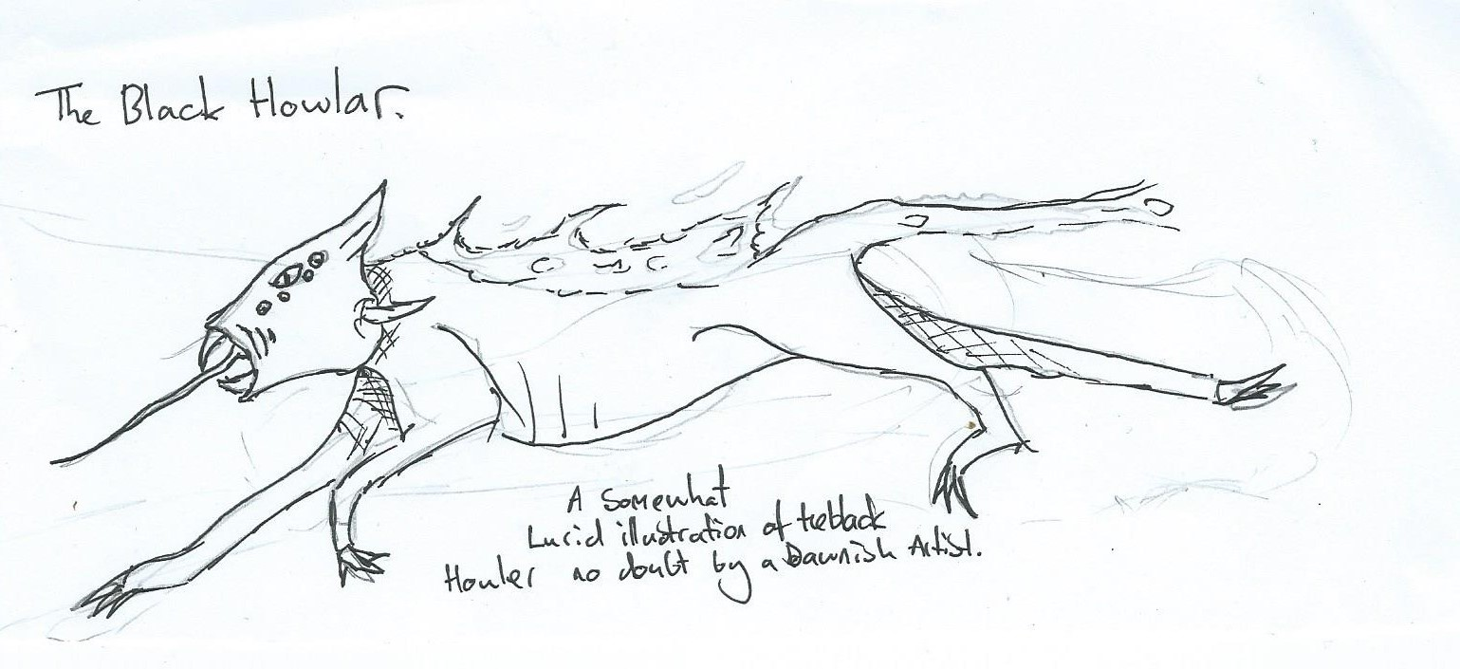
Whilst some have claimed to have seen the Howler and lived, no one has ever been able to give a clear description. Common descriptions are “wolf like” “red eyes” “fur as black as midnight” “as fast as an eagle” “as large as an ox”. Its one distinctive trait everyone is sure of is its howl – a bone chilling wail that cannot be mistaken for a fox or wolf. The wail and the disappearances on its stalking nights are enough to convince people of its existence but all attempts over the centuries to hunt or track it down have failed – sometimes with additional disappearances.
Local tradition has it that the beast enters Haros from the Cliff of Eyes and can only be warded against by flame and the bell ringing of the virtuous. So on nights of the new moon and especially on the Winter Solstice, the Suns of Couros chapter had the responsibility of building a large bonfire in front of the Cliff of Eyes, lit just before sunset and tended to till sunrise by guardians and servants of the chapter. Whilst the chapter bell, nicknamed the Howling Bell by locals, was rung in continual sonorous rhythm all night.
The Howler did not come every new moon or Solstice and it could be many years before the wail would be heard again and the disappearances restart. The bonfire ceremony and bell ringing, however, would continue every new moon and Winter Solstice, year in, year out – until the fall of Reikos.
With the chaos of the fall of Reikos, the influx of refugees, and the changing leadership of the Suns of Couros chapter, the ceremony was not performed at all during the first six months after the fall. Once order was restored, Exarch Silas decided that it would be inefficient to continue the practice in the present circumstances. It was an unpopular decision amongst the the other chapters but they could hardly argue against Exarch Silas’ cold and calm logic behind his decision. The vigil site was exposed beyond the southern walls and the guardians were needed for the walls, further, the incessant bell ringing would interfere with the bells rung in case of attack. The locals grumbled darkly about draughir and their ties to Winter but did nothing – fearing the worst when the Winter Solstice approached. However the Solstice came and went; with no wails and no disappearances except those accounted for as casualties of war. As each new moon and Winter solstice came and went by without the wails, the story of the Black Howler receded from people’s minds, focused instead as they were on the more immediate threat of the barbarian raids and attacks.
So far in the nine years since the fall of Reikos no sight or sound has been made of the Black Howler and most of those who initially complained have conveniently forgotten their superstitious worries. There are those, however, who do not forget and mutter into their cups on the coldest, longest and darkest nights that perhaps the beast is taking its fill from the barbarians - for now; growing stronger each year as the old traditions and protections are forgotten in the name of expediency.

The Lost Library
All the know the story of mad Emperor Nicovar and his campaign to destroy the Empire's Libraries. However this Imperial calamity had a local element to it for Haros and the Suns of Couros in particular.
Even in Nicovar's day, the Suns of Couros had an extensive library of Winter texts and, despite the chapter's seclusion, this was known to the Draughir Emperor. He sent troops specifically to Haros to ensure this library was destroyed along with larger, more well known repositories within Highguard.
The orders came as a surprise to many lore keepers and archivists at the start of the campaign but the Suns of Couros were forewarned by their draughir former librarian, Daniel, ringing his bell furiously from within the Cliff of Eyes supposedly on the day that the order was given to destroy his library. Retiring only weeks before to the Cliff, Daniel had felt the madness approach once he started hearing voices coming from the books of the Library and obsessing over the catalogue - convinced that books were moving on their own volition.
When one of the servants came to his cell to find out what was wrong, Daniel was insistent that the Library had to be moved into the Cliff for safe keeping. The servant thought it was all part of Daniel's encroaching madness and turned to leave him. However Daniel demanded that the servant at least take a message to his successor and former assistant Neriah - "the Serpent has been unleashed - it will consume all that we hold dear if the Library is not sealed within Cliff of Eyes before the next new moon".
The servant left the Cliff and faithfully took the cryptic message to the Neriah as the chapter's librarian. Neriah upon hearing the words spoken by his former master paled and hurried up to the Cliff to speak to Daniel himself. No one knows what was spoken between them but a short while later Neriah ordered his assistants to move the texts of the Library into the Cliff as fast as they could.
The Exarch of the time was away on Synod business and Neriah fobbed off those Council members who came to ask him what was going on. Three days later on the morning of the new moon, the last of the texts had been moved into the Cliff - all documented and listed in their new locations. That afternoon Daniel's bell rang again as Imperial troops loyal to the Emperor were sighted approaching the settlement. By this time Neriah's fellow magisters and Council members were demanding the return of the Library or at least an explanation of his orders and actions. They used the appearance of Imperial troops as the means to force him to explain himself. Instead of facing the troops and his colleagues, Neriah fled into the Cliff of Eyes with the catalogue and disappeared.
The commander of the Imperial troops was under direct Imperial orders not to reveal her mission to the chapter until the library had been secured, so she ordered her troops to search the chapter house in the hope that the Library would be found. When the word came back about what Neriah had done, she led her troops into the Cliff to root out the Librarian and the hidden texts - that was the last anyone saw of her or her troops. No sounds of battle were heard, no cries of terror or death came echoing out of the Cliff, just the gentle chiming of wind chimes as the summer breeze blew against its many cave faces.
Terrified at the probability of Imperial punishment over the disappearance of Imperial troops visiting the Chapter, as well as the implications of how they disappeared, the Council was unable to decide on a course of action. Eventually, after two days of inaction, one of Neriah's assistants, a draughir, braved the Cliff of Eyes to find out what happened. He did not find any sign of the troops, Neriah or even Daniel, and the Library, which had been so carefully stored and catalogued within several empty chambers had been chaotically strewn throughout the Cliff's corridors and chambers. Not only that, but many volumes had somehow had their folios separated and then re-aggregated with folios of other unrelated volumes. Carved in blood over the Frozen Portal of Stone and Woe were the runes of Irremais (Wisdom) and Lann (Bargains / Debt).
The draughir returned from the Cliff of Eyes and calmly reported his findings to the Council who again were hit by indecision. Only with the return of the Exarch and the news of Emperor Nicovar's madness and death was the order made to bring the texts back to the chapter house and to ritually cleanse the Frozen Portal.
Whilst the books were brought back into the chapter house, their reorganisation and and cataloguing was beyond successive librarians and archivists - many of whom swore that the books moved as if to sometimes confound or illuminate a researcher but always to undermine any attempt to catalogue their contents.

Slaves chains
The chains glint in the firelight. The chains of slavery that bound the Orcs that wore them. It made it easier for the slavers to forget that they were individuals, individuals who lived and died in those mines, who had husbands, wives, children, friends, who sang songs late into the night, telling stories of objects they once treasured, or of their homelands they would never see again. The forests and mines of Moresva and Lestazny ran on Orcish blood and toil. The Dukov family, like much of Ivarsgard, never questioned buying or selling Orcish slaves: they were a commodity – to be kept in good condition, and to be maintained like any other resource – but they weren’t truly people. Times change, but ghosts of times past never forget… or forgive.

Varushkan Story
“… and it’ll scoop out your eyes with its claws and eat them like cherries!”
Little Moths’ eyes widened in horror as her older cousins did their best to scare her with one of their favourite stories.
“It’s because the monster is angry at great-babushka. She hit it with a tree branch and then smashed in its eyes with rocks. It was a monster that came out of the hills of the North, the Seat of the Tvar, and when it came it would look just like one of the traders from Moresvah, the ones that sell those cinnamon buns. Nobody would know about it until they were mean to it, and then it would grow into a huuuuuuge feathery bird with a beak that would SCREAM and make your brain fall out of your ears.”
A little squeak emerges from the little girl, picturing the image of her older brother lying with blood draining from his skull, crying in pain. He didn’t like loud noises, and the thought of such a creature hurting him terrified her.
“But great-babsha got it? She killed it? It’s not going to come back for us, is it?”
The cousins laughed, not realising what Moth could see in her head. “Oh no. She just made it angry. And one day it might come back for YOU!”
They skipped away, leaving the little girl all alone by the tree. Sometimes, children can be cruel.

The Lost Lady of the Pines
In many parts of Varushka, like any other visitor, The Dead are always welcome at The Hearth.
Not the shambling abominations that are husks, nor the bones that are simply the carriage of the body, but the shades of those dear departed who have not yet crossed to the Labyrinth and may still have purpose, and are sorely missed by those they left behind.
As the fruitful year dies away and the first snows are soon to fall there are many homes where, one night, a glass of strong spirits and a honeyed cake are left at the hearth for dead, who are welcomed to that home or hall.
There are some who say this is just a tradition and a way finding solace in memory, but there are others who say that in the morning the hearth has been swept, a new fire laid and the drink and the cake are gone.
Not so peaceful is the hereafter for those whose graves are unmarked; whose bodies were not laid to rest with kindness and tears: Those who were lost in the forest and lost forever.
Lost, like the young woman, whose house was burned on her wedding night; her new husband slain as he lay in her arms, leaving her to run from their attackers. Run into the night, and run deep into the forest.
No quiet, tended grave or honeyed cakes for the young wife’s ghost, but the unending pain of her lost love, her wedding gown torn and taken to line the nests of crows and her bones gnawed by foxes, pierced by tree roots and clothed in velvet moss, among the quiet of the forest pines.
- * *
Some years later another young woman was on her way to be married. She was travelling from her Vale to that of her betrothed, escorted by her two brothers and their widowed father.
Although they stayed on the path, it was deep in the forest and far from help that they were set upon. The men fought bravely, allowing their sister, their daughter, time to escape as she fled into the trees.
The attackers followed her, baying like hounds, knowing it was only time before the girl weakened and they would fall upon her.
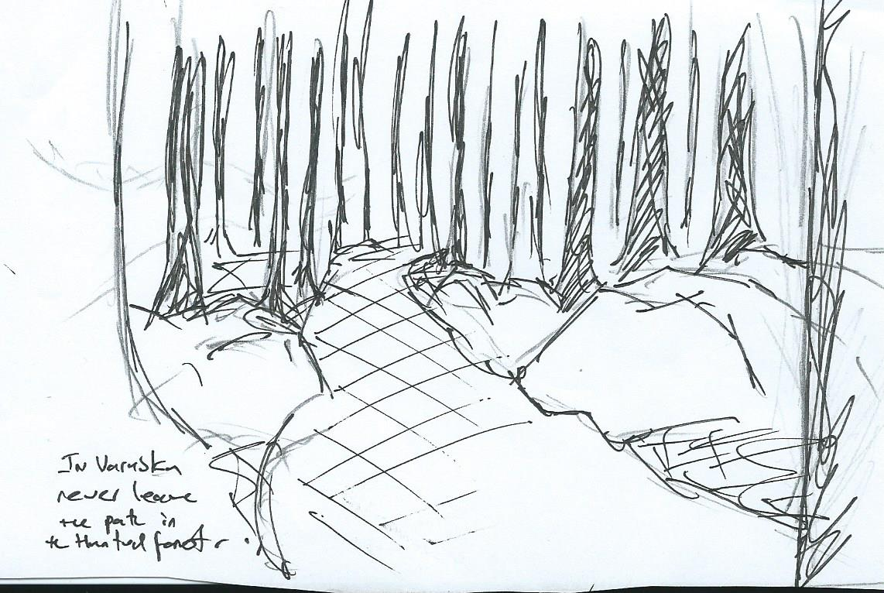

The pillared trunks of the pines grew closer and closer and the light from the sun grew fainter and fainter as hunter and hunted pushed deeper and deeper into the forest’s heart. Tiring, the young woman fell, gasping for breath, on the soft, deep, pungent carpet of needles.
As she fell, she didn’t notice that her soft hand closed around a finger bone, lying, thinly covered, on the forest floor; a finger bone that still bore a ring. A woman’s ring. A wife’s ring.
The young woman rose again, unthinkingly clutching the finger bone and its ring, but this time when she ran gossamer strands of mist followed in her wake, fanning out behind her, like the train of a gown.
Her pursuers didn’t notice the mist, growing and thickening around their ankles. In the heat of the chase they didn’t feel the unseasonal cold, dragging its nails down their legs.
Finally the young woman was cornered. In a forest hollow, against a low and ragged cliff, exhaustion took her and she fell down into the white vapours and they closed over and covered her.
The hunters slowed, knowing the chase was won, grinning and hungry for their prize.
But the figure who stood up out of the pool of mist was not their quarry. Glowing white shreds of chill fog rolled off the shoulders of the female form, hugging her like a silk gown. But it was the sight of her body that made the men stand as still as the trees that surrounded them: Roots and sticks and leaves and moss and stones and the creatures that crawl and wriggle through the litter of the forest floor combined to make a sketch of bones and hair and knotted, gnarly sinew. If, in life, she had ever been beautiful, she was now terrible to look upon and a host to long-brooded vengeance.
In the sudden silence a quiet creak was heard, like a branch in a night breeze, as vines and roots moved and twisted to allow the hideous figure to open wide her mouldered mouth.
And then she screamed.
And as she screamed all the horrors of the night poured from that mouth and the air was filled with shrieking bats and clouds of flapping moths and the howls of wolves and skittering, blood-eyed rats ran like black blood down her front.
Those men who did not – could not – run, themselves screaming, into the forest to meet their own, lonely fates were held fast where they stood. Not just immobilised by fear, but bound to the floor by reaching roots that sprang up through the ground, wrapping around their legs and bodies.
Great boughs of trees swept down and beat and broke them. Small animals crept from holes and burrows and ravaged their flesh, and all the while the entangling roots squeezed the breath from their bodies and popped their bones.
And as all this was happening, those men who now wept and called for their mothers could do nought but watch the ghastly spectre as she slowly processed towards them until, as their pain and fear was at its worst and their warm blood slid wet and hot down their broken bodies, she came to kiss each of them in turn; a kiss that was filled with the sweetness of leaf mould, as pine needles and soft earth poured into their mouths and filled their throats.
- * *
When the young woman awoke it was to find herself not far from the path she had fled from. Her Father, a bloodied makeshift bandage around his head woke her and held her, before he took her back to where her wounded brothers were resting.
She couldn’t remember how she had escaped or how she had found her way back. She couldn’t even remember where she had found the ring that she was now wearing next to her little finger, on her left hand.
But later, after she was happily married, her own wedding ring worn along with the ring from the forest, what she did know was that her babies slept sounder and longer than any of her neighbours’. And that, on a Winter’s night, if a honeyed cake and strong spirits were left out for the dead, the next morning her hearth was as clean as it had ever been and the fire that was now laid there burned longer and hotter than any she could ever lay. And no man or beast or wolf ever came out of the forest to bother that Vale, for a whole generation.

The King at the Crossroads
I have hunted many false virtue cults in my time, but the Kings cult is one of the more dangerous that I have come across.To give the foul creature its full name, The King that stands in silent rage at the cross roads is one of what I have dubbed the 'Nameless' or a specter.
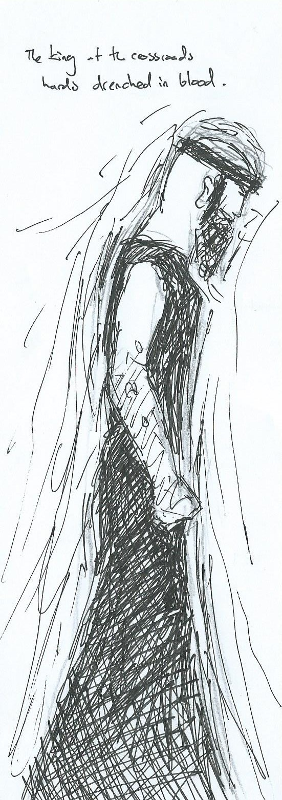
Many of the cults it spawns are ignorant of the thing they follow and seem to dedicate themselves to punishing those that they feel deserve punishment. Handing out their 'brand of justice'. For a while I believed that this creature was nothing more than a vengeful spirit of a magistrate, some ghost trapped forever judging it found wanting. I was wrong.
I came across one of the followers it spawned in Tassato, a young butcher who was killing those he believed to be cheating customers. When I cornered him i felt a terrible shame, a self loathing for all the things i saw in my self as weakness. That self hatred is something i have never felt the like of before, but the urge to punish others to feel better was also there. It was Adain, my apprentice that pulled my hands off the young butchers throat and restrained me.
It became apparent latter that the butcher had been given a coin as payment, the coin was in fact an anchor for the King and its influence had driven the young man insane. This coin was a very modern one, a ring in fact, so i can only assume it was an anchor created to spread this things vile influence. Think on this, just a tiny anchor, not its direct presence was enough to turn a young man. Its manifested presence must be as poison to the world.
From stories I have read and heard, The King's appearance is not some cowled figure from a Varushkan ghost story. It wears cloth of black yes, but it is dressed in a long war skirt and tunic. Its arms are bare and it's skin is alabaster white. On its head it wears a simple crown and its arms are covered in blood to its elbows. It apparently does not speak, but its stare is enough to make even a hero see their own sins, as if it can look into your soul and force you to pick at the sore on it you ignore.
I have also heard that there are those that willingly search for it. It can grant knowledge of peoples flaws and past events it has witnessed. In exchange it expects you to be judged and to carry out a task.
This thing is dangerous, when I exorcised that coin I felt it stare into me. It is utterly alien, it has no concepts of compassion or virtue, only a horrific capacity for judgement and self hatred, a self hatred it wished to pass on like a pox.
The Butcher, even after anointings and the help of a priest of pride killed himself. I exorcised and salted the bones under the sound of the local vigilance bell tower to be sure.

The Last Warrior
A long time ago, in the vale of Samizdat, home of The Family Kova evic, a great tragedy occurred. A group of children were playing in one of the outer fields of the vale. Somewhere they had been previously told they were not to be playing their games. The time had long passed for them to return home but, being young and defiant, they decided to finish their game before heading back.
As dusk began to close in around them an old woman approached. She bid them lead her back to the village for it was beyond freezing she said, and the darkness was almost upon them. Without a second thought the children did so, for it was only their pride that kept them out this late, the fear of being the first one to say they were scared to be so far, so late. Unfortunately for them their fear had been misplaced, for the very thing they should have been afraid of was being led by them right into the heart of their village.
Song – Snowbeast
Verses: Children playing in the snow Further out than they should go, Saw a stranger walking near -- Never stopped to think or fear.
Chorus: Hair like snow, eyes that gleam, Things aren’t always what they seem. Teeth too long, hands too thin -- Always look beneath the skin!
Greetings children, woman said, It’s so cold, I’m chilled near dead, Where’s your camp and family, too' Won’t you take me home with you'
Long white hair and eyes like ice, She spoke so fair and seemed so nice; Foolish children did not ask, Why she set them such a task.
They did not wait to find a guard, They led her straight to their own yard. They did not think to ask their kin, They brought her home and let her in.
And when she was well hid inside, Then she cast off her human hide. Her fangs grew long, her claws sprang free -- A hungry fierce now beast was she!
And all that night through every tent She stalked and slaughtered as she went. When the sun raised up his head, Half of all that tribe lay dead.
For pretty words and pretty whiles And pretty looks and pretty smiles -- Those folks where slain and scattered all, Because they let their caution fall.
The beast had laid waste to more than half of the vale within a few hours. It had torn through the schlacta that it encountered, leaving a trail of bodies behind it as it made it’s way through each village in turn. Starting with the smallest and leaving the largest central village ‘til last.
In the midst of the attack and band of wardens returned to the vale from their night patrol. They came upon the devastation in one of the smaller villages: Houses trashed and bloodied, bodies littering the paths, pools of dark blood against the moonlit now. It was a scene from their nightmares. The commander of the wardens quickly sent scouts to all the other villages to gather what warriors they could find. Most returned with tales of similarly horrific scenes from the other villages in the vale, and ultimately only a handful of warriors. They gathered together in centre of the village, 25 warriors in total, and the last warriors in the vale. Their destination had been made clear to them when one of the scouts had not returned. They were to head to the largest village in the vale, hoping that there someone had been able to put up some resistance to whatever force had been unleashed upon them. They marched to their goal, solemn and resolute, humming an age old
Varushkan marching song as they went.
Song: Marching Song (As to War)
Storms of winter cannot shake us As to war we go Thirst and hunger never break us Onward through the snow
Home and hearth we leave behind us As to war we go Those we love and ties that bind us Onward through the snow
Foul enchantments cannot charm us As to war we go Nor can curse or witchcraft harm us Onward through the snow
At our footfall all shall fear us As to war we go Foes will quail to venture near us Onward through the snow
If I fall upon the morrow As to war we go Raise a cup for me in sorrow Onward through the snow
Though cruel death may yet divide us As to war we go Fallen heroes march beside us Onward through the snow
Hail to those who went before us As to war we go Join me now in rousing chorus! Onward through the snow
It did not take the warriors long to reach the village, and no sooner had they arrived than a bloodcurdling scream rang out across the village, cut short at it’s crescendo. They ran, rounded the corner of the first home, and there it was, a seven foot tall monstrosity. The beast had glowing yellow eyes, fangs the size of daggers and white fur drenched in crimson blood, glistening in the moonlight. The beast dropped the tattered corpse of the poor soul that had let out the scream not a minute before and was upon the warriors in a second. Two fell almost instantly, then another, and two more. The beast seemed to move faster than they could think and within 30 seconds had dispatched more than half of the warriors and had barely sustained a scratch. An archer managed to shoot an arrow into it’s hide but this only deterred it for a second. Before he could notch another his throat had been torn out and the beast turned to finish off the rest of the group.
A minute later there was just one warrior left. The last warrior in the vale. He was a competent warrior, but even so he had survived thus far through luck and agility and now was alone against this massive beast. But he could not falter, he had to remain strong, for he was all that stood between this beast and the rest of the vale.
The last warrior in the vale stood firm, locking eyes with the beast, shield at the ready. The beast pounced; he blocked with his shield and quickly made to strike with his sword. A miss, the beast dodged too fast, and before he could regain his balance it swiped his shield to the side and dug it’s huge claws through the side of his armour, impaling him upon them. Then it flung him down into the snow like a discarded toy and skulked off towards the centre of the village.
And that was it. The last warrior in the vale lay bleeding to death in the snow. His cries of pain echoed through the vale and beyond, for it wasn’t just the pain of his wounds he felt. It was the pain that comes with loss. The loss of the whole vale, as it was sure now. There were no more that could stand against the beast. His cries of pain did not go unheard however, and so much death attracts unusual attentions. And, with half the vale dead and gone the wards were weak, allowing some strong spirits and the like through. One such spirit had haunted the vale for hundreds of years, and had once called the vale it’s home when it lived. It came to the dying warrior now.
Song - The Bargain
He felt his life drain slowly as the blood it flowed A river of pure garnet in the snow The spirit came before him in the moonlight glow “There’s one more thing to do before you go”
The beast still stalks the village on this night so cold Slaying all our people as it goes No-one has the strength to stop this violent foe They’d be dead before they moved to strike a blow
A bargain I can strike with you on your last breath But I cannot give the life back that was stole I’ll make it so that you have fight beyond your death If for loyalty you’ll risk your very soul
“Yes” he groaned, “Do it” And with that, the last warrior drew his final breath. But the spirit lingered over the warrior’s corpse speaking words unheard, bonding with the soul of the last warrior. Eventually, after a few moments, the warrior’s eyes opened. But there was no life in those eyes, not real life anyway. He stood up slowly, and began his slow march through the snow. Faintly humming that marching tune.
The villagers had gathered in the great hall in the centre of the village, barricading the door. But this was little use against the brute strength of the snow beast. It took only minutes for it to break it’s way through the doors and barricade, fuelled into a horrifying frenzy by the taste of fear and blood that hung in the air. The people we crowded in the back of the hall as far from the door as possible, many of them frozen with fear, some crying, others silent. They were sure of their fate. The beast stalked towards them, panting hungrily, although if it was only hunger that drove the beast it’s appetite would surely have been sated by now. When it was within a few feet of the nearest villager it stopped, sensing something behind it.
In the broken doorway stood the last warrior, drenched in blood, wielding two swords. Before anyone could take a breath the beast bounded over to him. He dodged, and struck, parried and struck, getting in two blows before the beast knocked him to the ground and was on top of him. His head almost fully within the beast’s jaws, it sunk it’s teeth into either side of his face, and pulled. The warrior didn’t make a sound. No scream, not even a stifled moan. He just lay there, motionless.
The back of the hall on the other hand was full of screams, which drew the beast’s attention. Flinging aside the skin that hung from between it’s jaws the beast made it’s way once again to the remaining villagers. But once again the warrior was on his feet. Now a horrific sight to behold; where there had once been a face was now a white skull, smeared with blood, eyes still intact and fixed upon the beast. With solid purpose he moved towards the beast.
The beast pounced again and tried to maul him this time, but the warrior felt no pain and undeterred struck blow after blow around the beasts head and neck. The beast broke off for a second, seeming to reassess the situation. This time it dove in and out, slashing and biting but trying to avoid the sword. The warrior though was not so concerned with avoiding blows. He took each blow to his body in order to gain the strike against his foe. He did not bleed and did not tire. The same could not be said for the beast. After a few minutes it was covered in blood, although now it was it’s own. It took another swipe at the warrior but fatigue and blood loss had taken it’s toll and it faltered ever so slightly. The warrior was upon it instantly, driving his sword deep into the beast’s side. The beast staggered, looked at the warrior and let out an almighty roar. As it did so, the warrior took the other sword and plunged it into the beast’s throat, and out through the back of it’s skull.
The beast slumped to the ground, and without looking at the villagers the last warrior of the vale turned away and walked out of the great hall through the broken doorway. He slowly walked across the village, past the freezing pools of blood, the mangled corpse of his cousins and ruined houses of all he knew, and deep into the forest at the edge of the vale. To what end, no-one truly knows.
Some say he still walks the forests beyond the edge of the Kovaevic Vale, vigilant against another wolf such as the one that wrought such devastation. There are indeed further tales of the nightmarish warrior coming to the aid of inhabitants of the vale, but he has not been seen in a generation. Some say the he has by now found a way into the labyrinth and has long since moved on, or will be reborn again and again as great Schlacta of the vale. To this day parents tell the tale of the Last Warrior to their children, as a reminder of the dangers of the wilds, the consequences of foolishness, the need for vigilance, and the power of loyalty.

In Summertime, when Children Play

In summertime, when children play
Upon the vale, not far away
There is a lonely ruined copse
Where Mikhail went and did get lost

Within the shaded, leafy tops
His feet upon the loamy moss
The air was thick and dim and hot
He found a tombstone, grim and squat

There beneath the breezeless shade
He wondered at the den he’d made
But he had scarcely ventured in
He heard his mother calling him

Before he turned his pace around
He picked a stone from off the ground
Forgetting beneath summer sun
The thing he’d seen, the thing he’d done

But deep below the stones so cold
A memory centuries old
It dwelt there until summer’s end
Entombed beneath the village fen

Dark things lay in wait for winter
When the sunlight doesn’t linger
As solstice graced the wintry vale
The wind was whipped to cry and wail

He woke to darkness with a start
The air was thick with magic’s art
He thought he heard without the door
A distant, angry, lonesome… roar

He was to his feet in a flash
And pulled aside the window sash
Stalking across the moonlit snow
Approached a figure, tall and slow

Slamming down the window grating
He collapsed and started shaking
Then across the iron railing
Sounds a gruesome finger trailing

After a time the noise passed by
To find another place to try
Mikhail let out a tiny yell
That it might test his kin as well

Towards his parent’s door he dashed
But from within they wailed and thrashed
He locked his chamber with the key
And wondered what the thing might be

What had they done to cause such hate
That this could be a fitting fate
He quickly came to understand
He’d damned them all with his own hand

Then from his door there was a scratch
And in his lungs his breath did catch
He closed his hands about the stone
And made to exit from his home

As he struggled with the grating
He heard wood behind him breaking
Through the crack were fingers poking
Grasping, reaching, blindly groping

Merrow
Ah, so many tales of Varushka tell of dark ways, hidden secrets of the forest, the harder task. But can these be the only things that make our Varushka?
And so I ask you to come to a riverbank in early May. The magical glint of sun off a dragonflies wing. The dappled gold caressing the waters inviting strangers to be friends, to dive deep and share its treasures.
Kier, our young Merrow of the story, gathers herbs for his Mother and Father. Patiently he harvests the greens, browns and greys into bundles for drying. The seeds carefully stored for our futures. His Mother and Father work alongside him, comforted in knowing his life is flowing smoothly.
But Kier has a wish. A hope. In these parts tradition acknowledges families by one name. No individual is greeted, they are one. In these gentle backwaters it almost goes without saying that he loves his kin, but Kier wants his own name to be called with respect and comradeship. And so he starts to think of how he can become different. Do something to bring him to his parents side, not stand in their shadow.
June brings His Mothers birthday and for a gift he presents a pouch woven from the reeds of the riverbank. His Mother has seen these before, many times - it is a young merrow who is shown this pastime to keep busy, out of curiosities way. But this one she sees is different: it is not only made with the young Merrow's hands and love, but a honed craftsmanship she has not known before.
A hazy July sees our young Kier selling herbs within similar simple pouches, and as the year moves swiftly on he creates more decorative patterns into the dusky evenings. And as we round into May once more we again find Kier harvesting with his kin, but with a changed smile and newfound vigour in his wake. The newborn season brings old friends as they make their way to trade, swap stories and celebrate life's circle of newlings and those who have gone to the deep. Kier's fresh eyes see newcomers along the riverbanks and with his families wares he moves forth to greet them warmly. His Mother smiles to see him grow into his fins.
Downriver, the marshtree's newest is an older Merrow, who has a quietness about him. He arrived in colder months but it has taken our young Merrow time to build courage to venture further. This marshtree shop holds delicately mastered pouches, garments and carriers which inspire - Kier has not seen workmanship of this kind before.
Kier introduces himself by name - not the families name but his own, proudly. The Gentleman smiles. No name is returned and he wonders if he has heard it yet through friends. His quietness is slowly distracted with the delicate stitching and tiny details interwoven into the everyday goods on show here. Kier exclaims his delight and unable to stop reaches out to touch, just remembering himself in time - he looks to the Gentleman 'May I?' A second, more warming smile is accompanied with a definite nod. Kier's hand touches the cloth of the bag, finding it almost melting at the gentle stroke. He pauses - the texture, the scent... He looks to the Gentleman to find he has moved silently to a garment at the back - the pride is evident as he invites Kier in to see. He moves inwards as the man gives him space to see the proffering. Maybe he has found someone he can learn from? The drape of the garment, the slightly odd shape of the cloth suggest something he has never seen before. The colour being so very familiar, whilst the fragrance softly nudges his mind... He turns abruptly, not having heard the feather like footstep which has placed the old Merrow beside him. A tendril brushes one shoulder, a hand firmly rests on his other. Kier moves...
May's dragonflies have long passed by, Traders say goodbye moving onwards for the new season. Summers tides ebb away and the families harvest ends once more. Kier's pouches in which they are now gathered have started to look tired. As old friends depart with fond farewells Mother and Father ask they same question of each, always hoping, yet knowing the unwanted answer. 'Have you seen him?'
Down towards the marshtree's they wander with their wares. The old Merrow is still there - stitching under the willows that reach over the sun rippled waters into the depths. A friendly greeting is called to him and in return, a graceful gesture welcomes the strangers to his shop. Mother looks in, intrigued by the delicate stitching, whilst Father stands a business like distance from the Gentleman. Is he in need of any herbs or potions? Can they head anything else his way? Is trade good? The conversation moves along with no surprises and the usual questions of strangers in passing, thoughts bobbing by. Mother comes out of the marshtree holding a small and intricate pouch. Father looks over - she holds it to herself. The colour, she says just reminds her of Kier.
The older Merrow has been so unassuming they do not realise until later that he has not spoken a word. But it is of no import. Mother has a reminder now until they find him, a pouch whose colour seems to echo a fading memory, the touch, almost the scent..

The Spirits in the Ice
The young boy set off from his home to visit the village in the next vale, travelling for what felt like most of the day and was both tired and hungry when he saw the lights of the its fires in the growing dusk. He could see the wardens starting to set defences, much as his own parents had, and he ran happily forward to join in with the other children in helping protect the village They were surprised to see him, as he was a stranger, but greeted him warmly as he explained that he wanted to join in casting the protective ward. He was handed a drum and he helped lead the procession around the village. They tied ribbons and bells to fence posts so the wind would alert them of danger, wrapped wool round signposts to confuse any mara as to where they were, cast bird-seed below windows so that any blood drinker would be forced to pause and count them, and so be caught by the dawns light and banished, and many other rites, some he remembered his parents doing others, were new to him. He then sat with other children and was handed warm milk and bread, which was not entirely to his taste as it tasted cloyingly sweet, but as a guest in their hearth he smiled and ate what was given him. Then before the Stenza brought out their instruments, the final ritual took place as small pottery dolls were handed to the children to place around the pond that lay in the centre of the town, still and black in the moonlight. One of wise ones, her blindfold covered in a dozen or more tokens or hair and brass, explained to the boy that years ago, in a vale some leagues away a foolish boyar broke treaty with the sovereign that made its home in the lake that provided food, and trade to his town. It had been a hard year and the Boyar hoped that the sovereign would accept a lighter sacrifice that in previous years. The wise one shook her head, foolish man thinking that such creatures had any understanding of mortal concerns, except when to use them to their own ends. The sovereign seemed to accept the offering and the boyar believed himself wise to have trucked with such a devil and succeeded, and all was well until the celebration of winters passing. As they set out stalls and marked out areas for dancing and feasting a mist rose from the lake and began to fill the town. This was not uncommon at this season, but it seemed thicker than usual and penetrated each room of each house despite shutters and doors being closed against it An icy sigh fell upon the entire town and the Sovereign’s vengeance made clear. Each and every village child was frozen solid, but not dead, the occasional blink, and look of despair reminding those who watched that this was not death, but something worse. Attempts to break the children out were disastrous as limbs and torso continued to twitch after the shards melted. It was only when spring proper came that the true price was clear. One by one each child melted away to liquid, twisted reflections showing they still remained trapped within as they flowed from where they pooled, into the lake, forever. And this is why, continued the Wise one, that at the anniversary of the sovereign’s vengeance, we must protect all water from the ground, as it can carry the spirit of the children into the living. So we place vessels around the water to capture the spirits safely. And here is yours, she smiled sadly handing the young boy the last doll, unsurprised as he faded to a cold winter’s mist and poured into the pottery figure.

The Corsair
The sea was still, its surface almost like a mirror reflecting the stars and the moon, Two coasairs sat just above the tide line, sharing stories and drinking. They'd met in a local bar, and moved to the cove when the bar had shut for the night. "Hmm, it's been a while seen I seen those stars like that." the older, grizzled veteran said, "Will they be out tonight?" "Will who be out tonight?" the younger man asked. "It's a long story, and it plays out every so often, when the Drowned Man is at his highest, and the Wanderer is just above The Three sisters , on a full moon, like tonight, those poor souls relive their last few hours." "Shouldn't a Sutannir deal with that?" "Hmm, well I'll tell you the story, I can't remember the year, a young corsair captain had met the love of his life, she loved him back, and they were due to be married on his ship, but the girl had another suitor, a rich merchant who coveted her beauty. She rejected his advances, as she wanted to live her life on the open sea, and he wanted to keep her on land." "Makes sense I guess." "Yeah, but the Corsair didn't know about this, and he was close friends with the merchant, so he invited him to the wedding." "Oh Virtues..." "Exactly, the Cosair had an old friend officiate the wedding, along with a Sutannir. Everything was going well, and people were getting very drunk. So drunk that someone hauled the anchor up and the ship began to drift. No one noticed at first, and when they did they were too drunk to care. Everyone except the merchant that was, and he could see the clouds building, a storm was brewing and only he knew." "This is not going to end well." "Look at the stars, of course it isn't going to end well. The storm hit and as the only sober person on the ship, the merchant takes the wheel, but he has read dark things, books and letters from The Faraden about their false virtue of, 'Justice'." the old Corsair spits the word with venom in his eyes. "He steers the ship straight for The Kraken's Teeth, those rocks there. They were all doomed when he made that choice and succumbed to the temptation of false virtue." "I see, and you expect to see this replayed tonight." "Maybe, but I've got a wedding to organise, cause that damn Sutannir is a lazy sod who won't be getting paid for the work I do that much is for certain." "Where is the wedding." "On an old friend's ship, over in the next cove, I would invite you, but I don't think you would fit with the number of guests invited." "I see. . ." "Well nice chatting to you, and thanks for keeping an old man company." The younger corsair could only nod in response. "Well, be seeing you." "Bye." the younger man gulped, and waited for the older man to leave. He looked out over the cove and saw the clouds begining to roll over the horizon.

The Copse
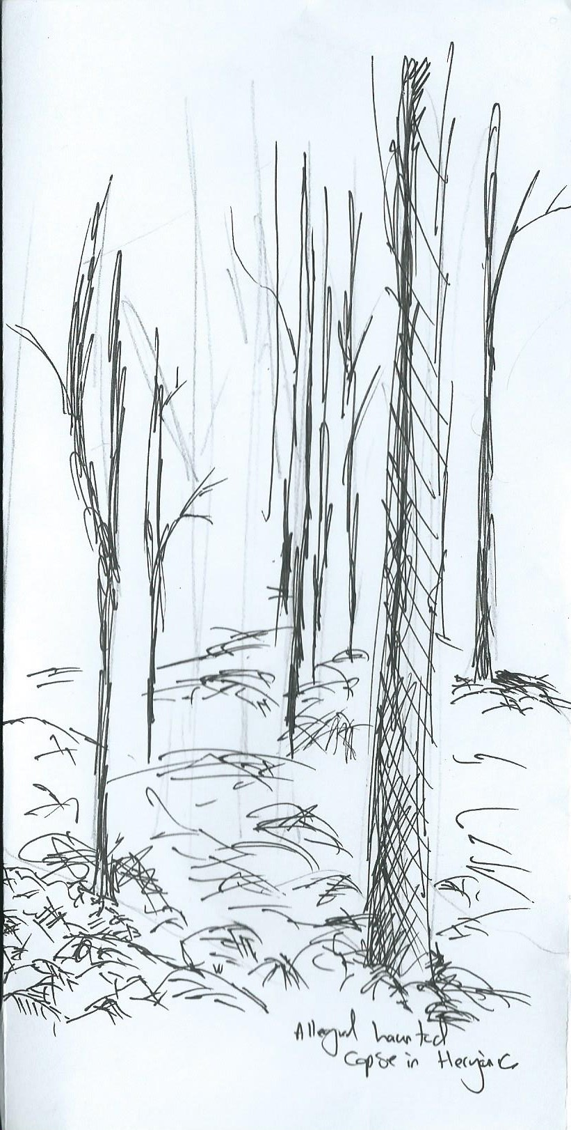
I was a few miles south of the Gate of Summer, deep in Summersend, where the sparse trees and rocks give way to a small clearing. It was sheltered and remote enough that any Navarri would pause to rest the night out of the wind and so I stopped to set up camp, dropping my burden to the floor and stretching my weary limbs. It was a perfectly clear winter’s night, the wind crisp and biting cold. Just as it reached the highest peak in the sky I saw the moons full grey light fall shine down into the clearing with such beauty that none could resist its quiet serenity. The trees were painted white and silver in the mystic light of the moon. And then it was that I realised that not a whisper of noise could be heard but my own slow breath and as I reached for the knife on my belt I turned the circle of the clearing. Not a single bird or beast to be heard or seen. I was alone. The rustle of the leaves and branches beneath my feet and the quickening beat of my heart felt unnaturally loud. It was then by the piercing silver light of the moon that I noticed that the ground beneath my feet, though littered with years of gathered leaves and branches, was smooth black stone, pricked with stars, like a reflection of the sky. With the dread of unearthing some fearful secret I backed away from the clearing, the cold seeping into my very flesh, a chill hand clasping round my pounding heart within my chest. A violent gust of wind swept through the clearing and on it came the whisper of voices, a haunting song on the breath of ice cold air. I grabbed my bag and fled. When I turned back, to check if I was being pursued, I caught the faintest glimpse of them. Gnarled and twisted they stood on the edge of the clearing, the palest white figures, standing on a mirror of the sky.

The Tale of Belyvolk Pass

There is a Vale, far to the east
A place called Belyvolk pass
No one talks about what lurks
Behind its doors of solid brass

They fear not its name, far from that
They fear not that which made its den
For this Vale, the wards did fall, they say
'could happen now, what happened then'

For the Vale was once strong,
Wards they put up at night
Yet 'cross the line they stepped
The wolves into the light

Swords were drawn, the shclata charged
Hard they fought, yet the sclacta fell
Common folk took up their arms
Yet the men and women died as well

Away, the children did flee
To the hall they swiftly ran
To their mistake, bared the door
'Trapped with the Whisp Man

His face Veiled, for he had no eyes to see
Yet he smiled, teeth like needles, 'sprung his trap
'Come forth and kneel, little Boyar' He cried
'Save the others, place youself upon my lap'

The young wolf shook his head
And took his father's spear
And Vuk thrust strong and true
'Thy lap shall not feel line rear!'

The Sovereign laughed, the spear passed through
And mocked the wolf's face turned red
'You cannot stroke me down with this, young Vuk
For you see, I am already, long, long dead'

He took the spear from his gut
And broke it against his knee
'Then face my wolves, children
No where for you to flee'

He raised his hands and the dead did rise
Upon their feet, blood dripping like rain
For each fallen warrior, his corpse did stand
And his soul next to him, bound by chain

They fought into the morning
From the hills the sun did wake
And blind the eyes of the dead
This chance, the kids did take.

Out the door they fled; the wolf at the helm
Their guts and their souls did churn
To leave the Vale, and those that died
Together, They swore they would return

That is the story of the children
And their home that they did leave
Now they are all fully grown, together
They are the wolves that reave

Lead by Vuk, the one who eats the hearts
With fair Mia, who is to be a bride
Loved and promised to Ranko, the mage
And Kaiser, whose talents Vuk does hide

Pavel, the boyar of his ship
The sea he calls his home
And Triska, often beside him
Studying an musty tome

These are the faces you'll see in Anvil
The wolves, welcome all without a vale
And last but not least: The Lion, Ash
Whose hand n' pen did write this tale

Although I only knew them
Lost a decade before that day
I shall still stand beside them
The warriors with I used to play

Trystan's tale
The small outpost in the hills North of Miekarova was silent and still. Trystan had been watching from woods just outside the settlement, for close to 3 days now. There was a report of a raid, sounds of steel on steel, battle cries and agony, battle and death. Yet despite being a Navarr scout, short in neither experience nor talent, he could find no signs. No tracks in or out, nothing disturbed or taken in the huts, no broken weapons or shards of armour. Everything left tracks or signs of passing, more so after a battle or raid. Even if someone attempted to cover their tracks, still there were signs. Yet now as the sun dips below the horizon, he hears movement through the trees, but nothing moves, the forest is still. Trystan readies his swords, against what he didn’t know.
Trystan pondered this, renowned for being a “sneaky bastard” by the men he served with in his youth, good as he was, even he left signs of passing no matter how careful he was.
As he gazed once more upon the settlement, of no more than half a dozen huts, the hearth fire at its centre began to glow as if lit recently. Absent was the smell of smoke and burning wood. He turned his attention back to the forest. Now he could hear the rattle of armour, of swords being unsheathed and the murmur of conversation attempting to be quiet. Trystan stayed hidden, and did not move, still puzzled by what he was hearing. Sounds of movement through the trees. Yet the trees did not move. Now he could see the glow of torches, yet as with the hearth fire, no smell of smoke. Using the cover of the trees he moved towards the torch light.
Then he saw them, what appeared to be men and orcs. Again was absent the smell of burning torches and now he was close enough to feel, the heat also was absent. They were clearly intent on raiding the settlement. A good thing it was empty, Trystan thought. He decided to wait until they moved closer to the settlement before picking them off one at a time. There were only ten of them, a petty feat for the growing legend of the “whispering death”, a tale growing ever taller by the men he served with, of his ability to whisper in your ear before you see him and then it’s too late.
The Raiders began to move, weapons drawn. Trystan crept a few paces behind the last man in the party, staying upwind so as not to give himself away. He knelt down to examine the tracks they were leaving, there were none. Then feeling that the last man was far enough behind, Trystan struck. His short sword slashed towards the last man’s throat. The intent to stop him crying out before his long sword finished the job. But rather than carving flesh his swords struck nothing but air. More disturbing was the fact that the last man paid no heed to Trystan’s actions.

The Slave
Light locked away, stolen, taken like my freedom, as if buried by an avalanche, so deep I don’t know which way is up, long forgotten is the sky or the scent of fresh air. All too familiar is the stale stench of sweat and rotten meat, mixed with green iron. The stench attracting insects, bursting from the earth, mistaking the scent for decay. Barely able to focus, soot settled on eyelids to the point of almost sealing, scoured with grit every blink is damming, the world has long lost its colour. The very air is poison, breathing the black-death, watching the thick mist glisten, swirling like decorative iron work, rasping, as each breath is heavier than the last, choking as I inhale the dust , it compacts and settles within.
Shifting weight from thighs, to lower back and over shoulder, every muscle fatigued barely responding to my command, every tendon stretched to the point of tearing, every bone feels shattered from within. Clanking and piercing, rings of the pick, as the axe clashes and resonates against rock. The splintered wooden shaft shreds as it passes through my hands, flaking flesh and half dried blood. Collar, cuffs and chain corroding and chafing, they jingle in jest, with very swing.
Beyond the point of exhaustion I stagger and fall. I’m looking sideways through the soot blanketed rocky ground, I spot a hessian scrap, old, torn and tattered, much like my own, maybe it was from the others? Out of some symbolic longing for company, or for comfort I attached it to myself, wrapping around hand and under shackled wrist.
Voices... like my own... Am I dreaming... have I fallen unconscious? These words, these thoughts they are not mine, the things they say, so angry, full of hate, they are far too disturbing. Shouting Screaming, Drums Beating, like waves of the sea crashing against my head. White noise, distorting a droning bass, thundering, the metronome, louder with my hearts beat.
Am I at my limit? Has mind given out before body? My heart is now racing, pounding, I can feel it pulsating in hands, chest, throat and ears, now numb to sensation my body is buzzing. In the chaos, among the shouting and screaming and swirling hate, there is a whisper, spoken so gently it stands out above the others, it barely uttered the words...
“born free”...
The maddening sound now dumbed down, voices still speaking of ill intent. The crack of whip on back pulls my focus back to reality. Parting my hessian clad back & skin, split open like dough under a baker’s knife. My tormenters beer battered breath spits through his beard.
“BYORN VTHREE... YOU AREE BELONGING TO VUSS NOW”.
Hope should be extinguished, spirits broken, but all is not lost....
How did he hear it too? Had I uttered these words to myself, or did he hear them from someone else? The widened eyed and deer startled look on his face, why was he shocked to hear it... Had the others uttered these words before me? Is this what they whispered to themselves, at the price of having tongue torn from face? Is this why we were separated, do these voices bind us, can these voices reunite us?
Although unsettling to both my tormentor and I, It seems these voices, these words have power, I shall need to listen more...

Laal and the Bell
There once was a child named Laal. Her camp was small, and there were not many other children for her to play with. Instead, she liked to wander out by herself in the hills, talking to the sheep and the birds. One day, she discovered a cave, and inside she found the skeleton of a lonesome Orc, with a golden bell in his hand. There were no others with him - it is bad enough to walk alone in life, but this unfortunate orc had to walk alone in death, too. He had nothing on him to discern his identity, only the bell remained, but Laal wished to know more about its owner. As she took the bell, the remains of the orc crumbled into dust. First she took it to her mother, but she didn't remember the bells owner. She rang it and shuddered, 'oh, what an awful noise!' Then she went to the shaman. He looked long at the bell, and weighed it in his palms. 'I don't remember him. But even if I do not, the ancestors will look after him.' Laal explained that she found him unburied, alone in a cave. The shaman's eyes saddened. 'A sorrowful way to die, without friends or brothers by your side. Maybe you should remember him, as others could not.' Laal like this idea. She would do well by the lonely orc, and remember him.
She slept with the bell by her bed that night. 'You found my bell.' Laal awoke with a start. What was that noise? An ancestor? She had heard they talked to us sometimes, but this wasn't like the mad shouts of shaman or warriors. The voice was serene and calm.
'Do.. You want it back?'
'No child. But would you ring it for me? I haven't heard it for so long.'
'I can't, mother is sleeping.'
'Please, the bell.'
'No.’
'The bell!' It said again, firmly. Laal shook her head and tried to go back to sleep. 'THE BELL! The voice shouted. Scared, Laal obeyed. She reached to the bell with a shaking hand and run it once. The voice stopped. 'Laal!' Her mother whispered loudly, ‘Be quiet while others sleep!' 'Sorry' she muttered, and lay back down to sleep, clutching the bell to her chest. The bell, the bell, the bell- The voice came again, repeating its words endlessly. Laal rung it again and the voice stopped, obviously satiated. 'I won't tell you again young one! ' her mother screeched. Laal kept silent the rest of that night, but the voice returned, screaming at her to ring the bell. She was silent, but she did not sleep. When morning came she sprang out of bed, the voice demanding as ever. She shook it violently and sighed peacefully as the voice faded away, but her mother grabbed the bell and wrenched it from her hand. 'I've had enough of this thing, I will give it to the smith to destroy.' Laal screamed 'No! If I don't ring it, the voice will come back!' The voice screamed at her. 'THE BELL!’
Laal shrieked. She snatched the bell from her mother’s grasp and ran to the other side of the camp, ringing as she went and weeping with joy. No one could stand the noise, but to Laal it was the most wonderful thing she ever heard. Campfolk ran from her path, covering their heads and blocking their ears. Even the sheep fled from the noise as she ran into the fields. She ran as fast as she could, still ringing the bell, all the way to the hills, never to be seen again. Many seasons passed, and a legion camped at the foot of a hill. A young Orc boy came to a cave and saw a beautiful bell, in the hand of a dead, lonely Orc. As he grasped its handle, he heard a small voice
'You found my bell.
Would you ring it for me?
I haven't heard it in so long.'

Lithaven
Chronicler’s Note: These writings are not to be circulated without the express permission of the Head Chronicler of the Guild of Chroniclers in Tassato. Any illegal repetition, copying and distribution will be prosecuted and sentenced accordingly.
In the northern corners of Liathaven, during of the Year 72 under Empress Teleri the Pious’ rule, twenty-eight Navaar Steadings and Stridings banded together to fight back a large Jotun incursion.
Where Bregasland and Liathaven meet the edge of the Empire lay the Crowfields, a bog of low-hanging willow trees and mud that had swallowed many unwary travellers. It was here the Navaar forces struck the oncoming barbarians, the shifting wet sands and dense forests suiting the Imperial forces that harried the Jotun Orcs mercilessly and it looked like the incursion was halted until the Jotun cast the most horrific of spells. Whatever bargain the Jotun struck with the Realm of Winter, it was not one that saved them and it proved to be disastrous for both forces. The chronicler Illyn Frostreach wrote what happened during those forsaken days:
The campaign has advanced well. So far we have slain four considerable companies of Jotun barbarians, warlocks and beasts of war. The council of Brands is to elect a leader of our military forces though I think it may be a wasted effort as this war looks nearly won before it has started.

We have received word from the Empress to drive the Jotun armies to our borders and advance no further. Some grumble that she is too cautious but I agree that we are best not to overextend ourselves beyond the Crowfields. The Jotun armies continue to press through the swamps like a bull harried by wasps but Navaar venom is far more potent.

Cut of the head of the snake and the body dies, the common saying of war. It is true, four Jotun chieftains have been butchered and their heads put on spikes. Today is a glorious day for the Empire and for its Navaar defenders.

Jotun raiding parties continue to strike our forces but the Bonespear and Wraithmarch scouts have said they’re falling back to escape the swamps and leaving behind much of their tools of war.

The camps we have raided have turned up only bones. There is no water or supplies and no slaves that tend to the camps, it is deserted. The trees have started to die, there is an unnatural pallor to the clouds and the swamps have started to dry up. Our Vates have been unable to make sense of what has infected the lands but our mana crystals turn to dust the moment a spell is cast and no Eternals or heralds will answer us. Tyrullyn Briarbane, elected leader of the Thorns, has tried to dispatch ravens to the Empress but the birds will not take flight. Nor do hens lay eggs and the livestock are beginning to waste away. There have been calls for retreat but Brairbane will not withdraw his forces until the Jotun are driven out entirely.

Our supplies are running out, the rations we give do not fill the hunger that we all feel and many have begun to starve. Brairbane refuses to turn back until the Jotun are destroyed but we have not sighted any of their forces in over a week. We find only armor, weapons and gnawed bones. The council of Brands is divided, the political deadlock has caused infighting amongst the stridings and three have left so far, taking their supplies with them. We have had no word from the Empress, no animals have been seen by our foragers and the local flora and fungi has spoiled. I fear we are forsaken.

Brairbane has been killed by his own kinsmen. They were mad when they were captured, screaming about rats and hunger. They were executed but their bodies went missing before they could be buried.

The scouts refuse to head out into the swamps. I don’t blame them. I hear chitting and scurrying on the edges of the camp and at night when I lay in my tent I feel things crawling over me. I do not sleep. No one does.

Four more died today, their bodies wasted to nothing. Their bodies disappear but it is an unspoken fact they are in our stew.

We can’t find our way out of the Crowfields. We have found Jotun Orcs that have starved, affected the same way we are. They tasted foul.

Rats are everywhere. I feel them on my skin when I’m not looking.

The Thorns have begun killing at night. People disappear. Either they will kill me or the rats will. The Crowfields will be our tomb.

I killed a man today. He tried to eat me but I stabbed him before he could. I don’t want to eat him but my hunger is so great.

I am alone. Those that walk with me are no longer human. We walk until the sun falls and then the strong eat the weak as the moon shines on us. The rats gnaw the bones.

Death surrounds us.
What became of the Navaar forces, it is unknown. A mass grave of Human and Orc bones were found in a pit at the centre of the Crowfields, amongst the remains the writings of Illyn Frostreach as well as armor, weapons and various trinkets and clothing suggesting the grave was used more as simply a place to throw the refuse of the Imperial and Barbarians forces. No trails or markings were found to suggest the Navaar forces had wandered at all, their camp had not moved from where it had been at the beginning of the campaign. A large circle was found around the perimeter of the camp that had been worn down by numerous footprints, both Orc and Human. It is not known how remains of the Orcs and Humans came to be at the centre of the Crowfields, some forty miles away. It is worth noting that amongst the bones of the mass graves were thousands of smaller bones, those akin to a rodent’s.
Empress Teleri ordered the site to be purified by fire and exorcism, twenty-five priests from Highguard were brought to ensure the spirits of the dead passed on and did not linger.
In the following months the Crowfields did indeed dry up, the reason is unclear whether it is natural or supernatural. The willow trees eventually rotted and died, in their place are small oak saplings have began to grown. The Empress situated a small fort on this site as well as a garrison of Navaar Thorns and their families, possibly to remove the stain on Liathaven’s soil.
The wood harvested from the oak trees is initially a dark red though after treating the wood it fades to a rich brown. It’s been found to be more sturdy and lighter compared to most oak though a law quietly passed by Empress Teleri forbids the harvesting and use of the red oak wood by any Imperial army.
No monument stands for the dead, no corpse grove nor are their deeds officially recorded in the Imperial histories. Today the Red Oak steading sits atop the site of the camp, the red oak trees seeming to be the only reminder of those damn souls.

Little Kasia, or the Volodny Who Collected Children
Once upon a time in a Vale not too far away from ours there was a little girl named Kasia, who was the kindest girl in the Vale. She was forever rescuing lost birds and bringing forest animals with broken legs home to care for them. One day Little Kasia was walking in the forest not too far from her home when she came upon the cages of the birdcatcher and inside one of them was a golden bird. “Oh help me, my little ones with starve without me!” The little bird cried. Kasia knew that Afanasy the bird catcher would be angry if she let the bird out, but the little bird’s voice sounded so sad that she felt she had to, so she did. “Thank you, thank you!” The bird said. “One day I shall repay you, I promise.” And it flew away. Little Kasia sighed, for she had seen the birdcatcher in the distance, so she scampered away. She ran for a little while but then realised she had run out of the parts of the forest she recognised. She turned around, but had found she was quite lost. Suddenly a man appeared as if from no-where, a noble looking boyar dressed in black and sable furs. “Are you lost, little one?” He asked. “Should I take you back to the Vale?” Little Kasia was simple and innocent and thought the best of people despite all the warnings of her family and so she went with the man. He brought her not back to her Vale though, but to a little hut. “Come inside and have some bread and milk.” He said. Little Kasia went with him, and he seated her on a small stool inside the hut as he went out the back to look in the stores. All at once the ghosts of three little girl children appeared. “Oh little girl.” They tallest cried. “You must not eat the bread or drink the milk, for if you do you will belong to Vatsyav the Sable, the Volodny who collects children and he will kill you and put a spell on your bones so your soul cannot enter the Labyrinth like us.” Little Kasia was very frightened and asked why this was. The next youngest ghost cried “Because his youngest most beloved daughter betrayed him and joined the forces of the First Empress, and now he takes his revenge on the girlchildren of Varushka.” “What should I do?” Little Kasia whispered. The smallest little ghost whispered back. “In a box by the fire you will find my smallest fingerbone and my friend’s smallest toe bone and lastly the smallest bone of my other friend’s ear.” Take them and run from this place and then when Vatsyav chases you, throw them down.” Little Kasia did as she was told, and ran away from the hut, just as the man returned – as she ran she saw that there was a dent in his fine tunic where his heart should be. He roared and ran after her. Little Kasia threw down the fingerbone and at once a great wall of ice rose up between her and Vatsyav and she ran quickly away. Angrily he used his magic to shatter the ice and began to gain on her. Little Kasia threw the toebone down and it sprang up and became a wall of rock. Just as she was getting away, she saw Vatsyav shatter the wall of rock and come after her. At last she threw down the smallest earbone, the little stirrup, which grew into a great man-trap and caught around Vatsyav the Sable. Little Kasia ran and ran until at last she could see the shining granite of a road ahead of her and her little heart leapt. Then she heard a great snapping sound, and saw alas, Vatsyav the Sable had broken out of the man-trap and was coming after her. “Oh, help me please, somebody!” Little Kasia cried. All of a sudden, a great flock of birds flew out of the forest, with the Golden Bird like an Empress of Birds leading them, and they attacked Vatsyav the Sable, pecking at his eyes. Little Kasia cried out with joy and gratefulness and ran until she reached the road, and did not look back until she was safely home.

